**Assignment 1 Report**

#### course: COMP9444

#### term: 2020T2 full name: Zhaokun Su

#### zID: z5235878

### Part 1: Japanese Character Recognition

1.Model Netlin:

Required: Netlin model computes a linear function and of pixels in the image, followed by log softmax;

After 10 Epoch: the result figure shows below:

Final accuracy: 70%

Confusion matrix are shown below:

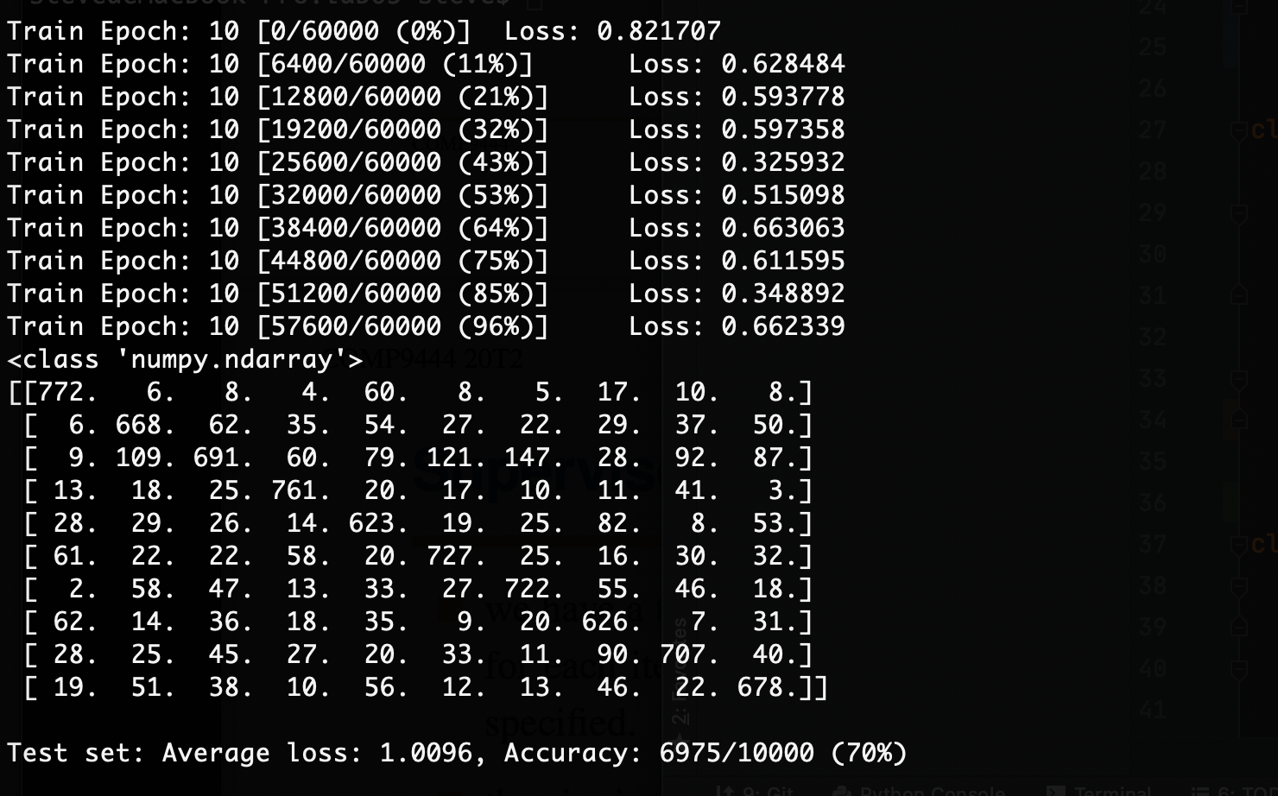

2.Model Netfull:

Required: Implement a fully connected 2-layer network Netfull, using tanh at the hidden nodes and log softmax at the output node;

Choosing different values for the number of hidden nodes:

When we choose 30 nodes in the hidden layer:

After 10 Epoch: the result figure shows below:

Final accuracy: 78%

Confusion matrix are shown below:

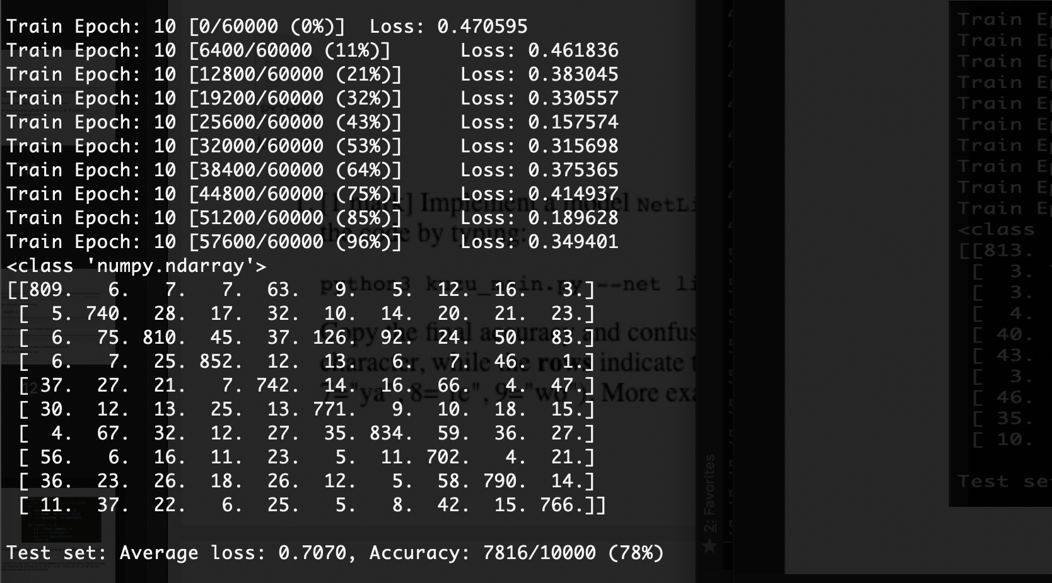

When we choose 50 nodes in the hidden layer:

After 10 Epoch: the result figure shows below:

Final accuracy: 81%

Confusion matrix are shown below:

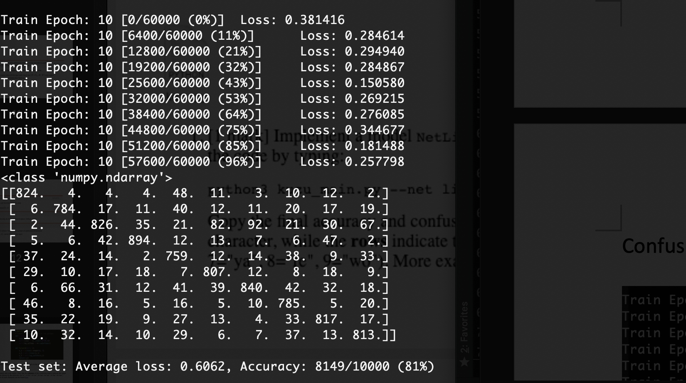

When we choose 70 nodes in the hidden layer:

After 10 Epoch: the result figure shows below:

Final accuracy: 83%

Confusion matrix are shown below:

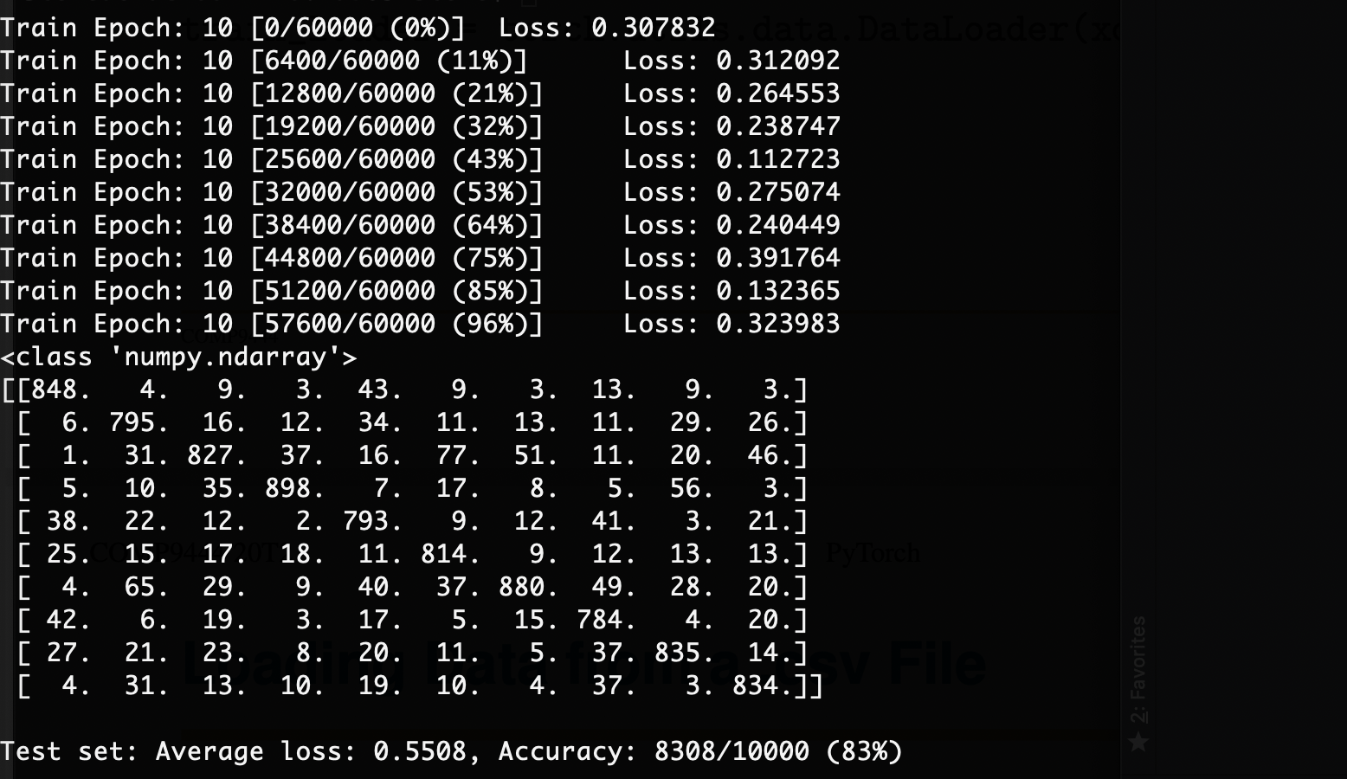

When we choose more than 70 nodes in the hidden layer, we could find that there is little change in final accuracy, so we choose 70 as our best number of hidden nodes.

3.Model NetConv:

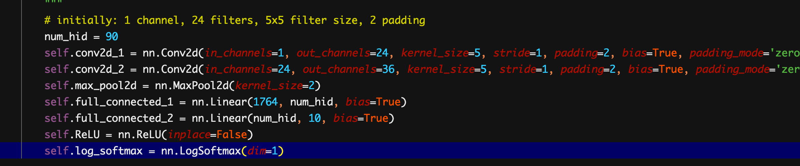

When we create our convolutional, we use two different combinations of parameters:

In the first convolutional layer: we use 24 filters and kernel_size 4 for each filter;

In the second convolutional layer: we use 36 filters and kernel_size 3 for each filter;

And we add max pooling approach every time after convolutions with max pooling size 2.

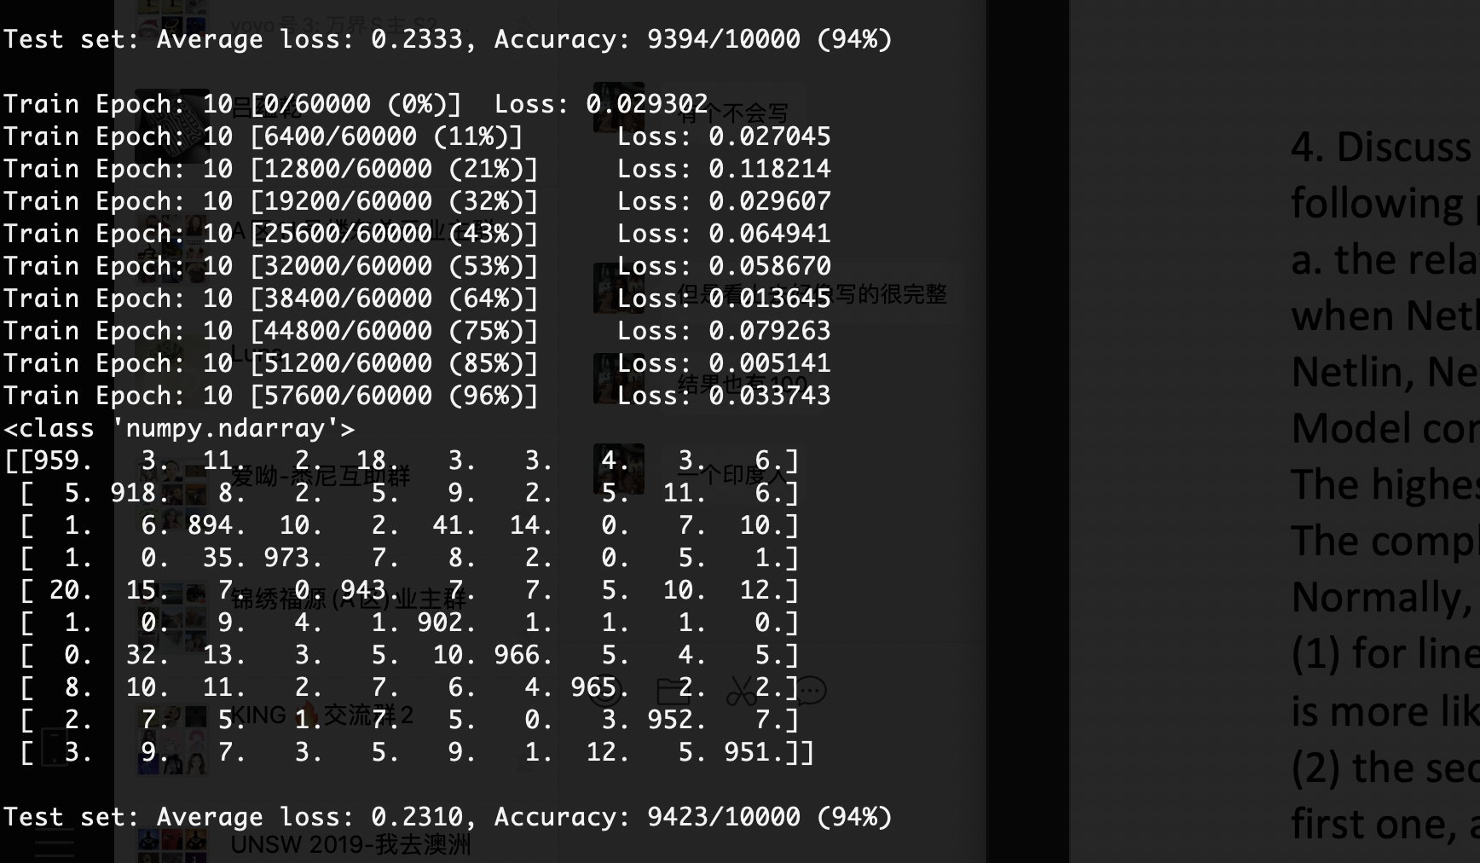

We can see that after epoch 8, the accuracy of our model had reached to 94% successfully.

**4. Discuss what you have learned from this exercise, including the following points:**

**a. the relative accuracy of the three models,**

when Netlin < Netfull < NetConv we look at these 3 different models: Netlin, Netfull and NetConv.

Model complexity: Netlin < Netfull < NetConv;

The highest accuracy: Netlin (70%) < Netfull (83%) < NetConv (94%)

The complexity of networks we established is increasing.

Normally, the more complexity the model has, the higher accuracy it gets.

(1) for linear network Netlin, the structure is not complex enough, which is more likely to be underfitting. And the accuracy is relatively lower.

(2) the second network Netfull has a higher complexity structure than the first one, and there are some improvements in terms of finaly accuracy.

(3) As our input data is of form of image data, the application of convolutional layer is more suitable for processing image-based data. It is mainly because convolutional layer could extract features and insights of behind an image according to the data we obtained. Compared with the other model, training a convolutional model is a better choice for image-based data representations.

**b. the confusion matrix for each model: which characters are most likely to be mistaken for which other characters, and why?**

Firstly, we have a look at our dataset image:

0="o", 1="ki", 2="su", 3="tsu", 4="na",

5="ha", 6="ma", 7="ya", 8="re", 9="wo";

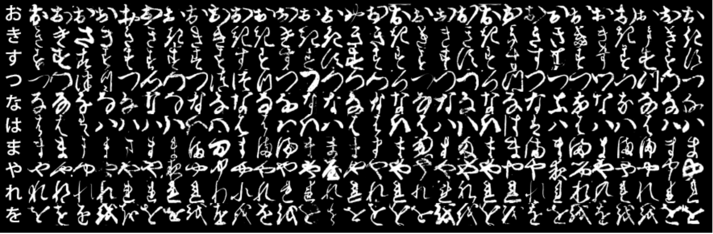

For Netlin:

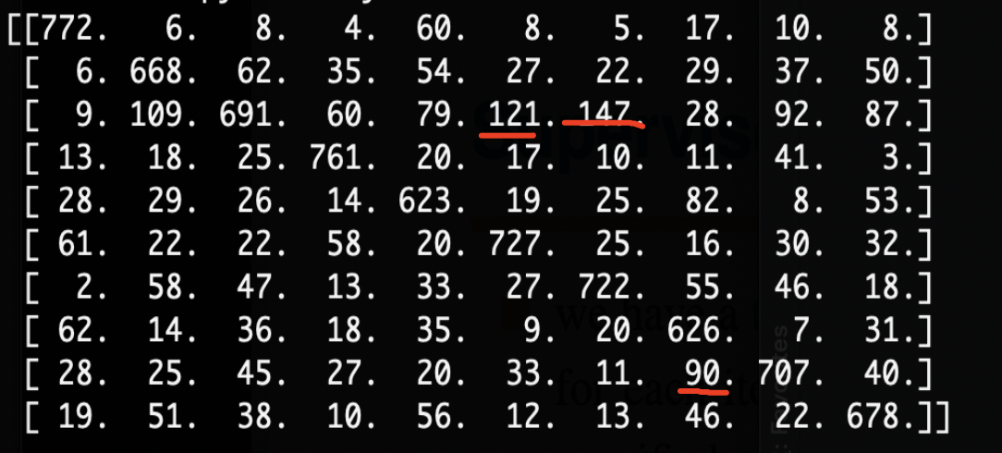

The writing format of 3rd character ("su") and 7th character ("ma") are similar, so it is easier to make a mistake with these two characters.

For Netfull:

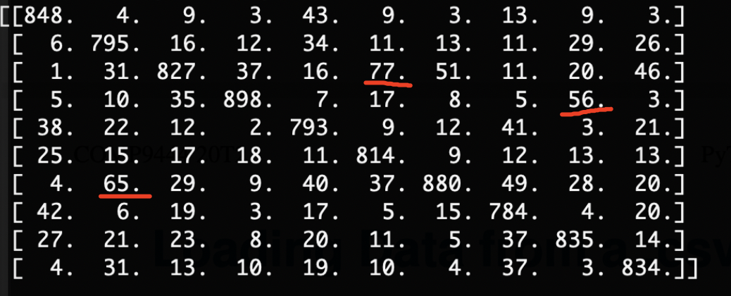

For Netconv:

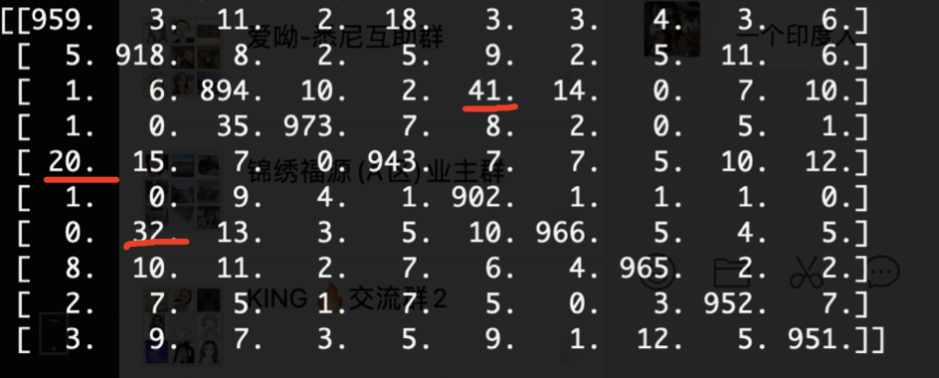

And we can see that 3rd character ("su") and 6th character ("ha") looks like similar because 6th character ("ha") contains "ha" character shape on the right part, maybe this is the reason why it is easier to make a mistake with these two characters.

**c. you may wish to experiment with other architectures and/or metaparameters for this dataset, and report on your results; the aim of this exercise is not only to achieve high accuracy but also to understand the effect of different choices on the final accuracy.**

In the convolutional, I have tried two appoarches:

One is the original one, we get two convolutional layers without pooling layers after them, and we get a average accuracy of 92%

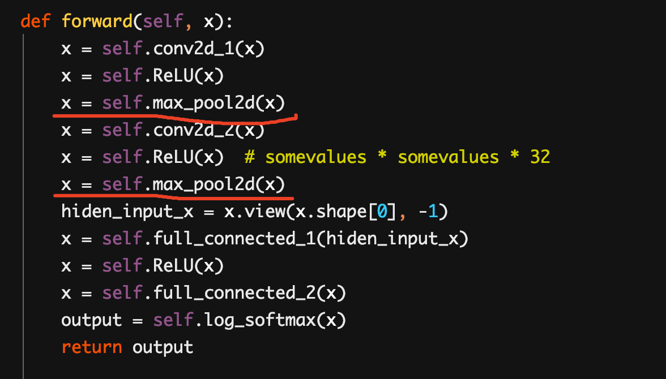

Another one is implemented by add pooling layers after each convolutional layer and two extra convolutional layers, which can get a higher accuracy during training, with a range from 94% to 95%.

Reason for this maybe is our model complexity increases by adding more convolutional layer for our problem and adding max pooling layer seems more likely to fetch right features about our images.

### Part 2: Twin Spirals Task

1. code is seen in file spiral.py

2. we run command in terminal:



In 2800 epoch, we get 100% accuracy.

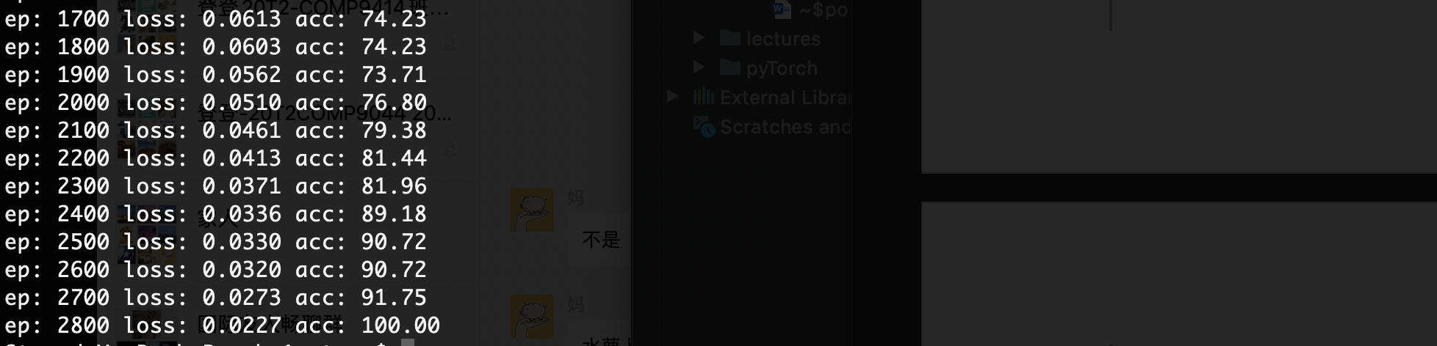

And we get our output png figure:

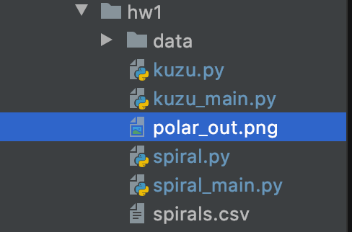

The result is shown below: polar_out.png

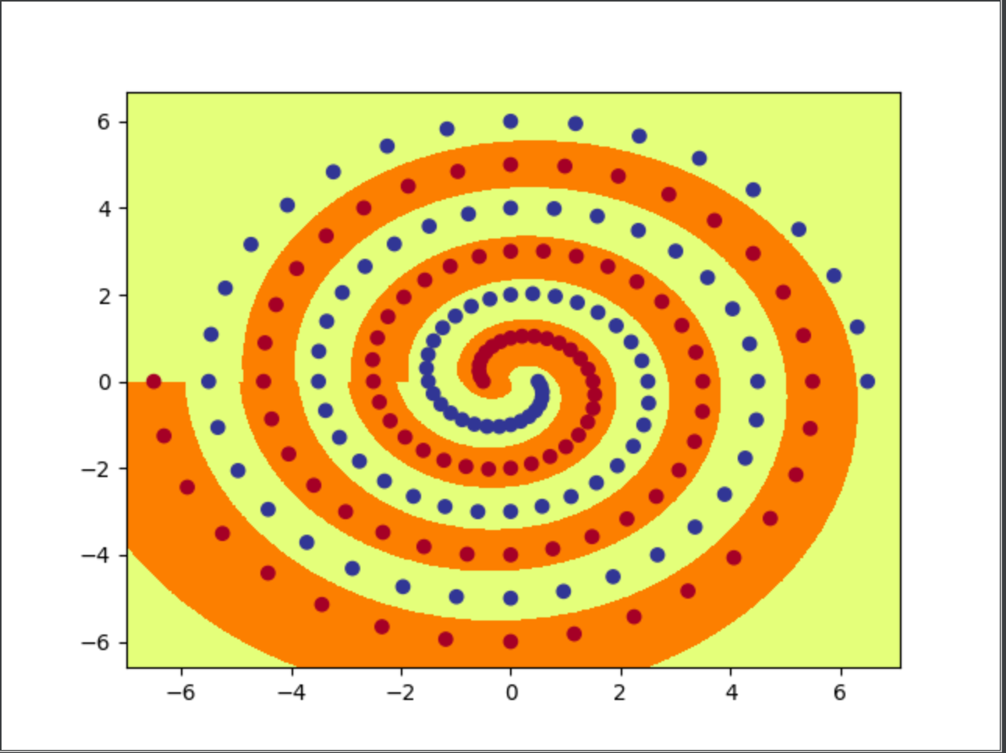

when we try num_hid to be 9, 8, 7 and 6 using command:

python3 spiral_main.py --net polar --hid “num_hid” –epochs 20000









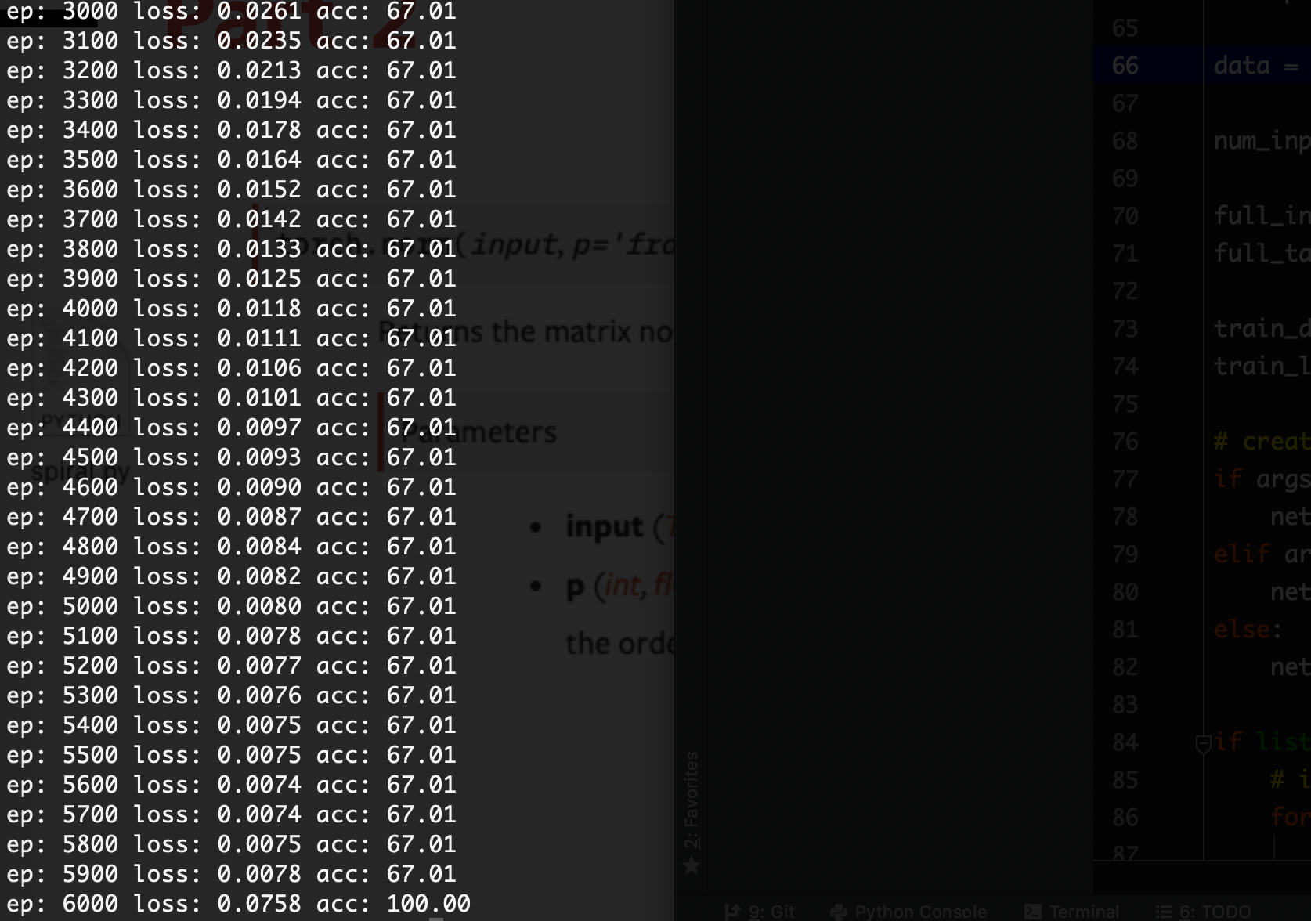

The figure below is figure generated when hid_num = 6

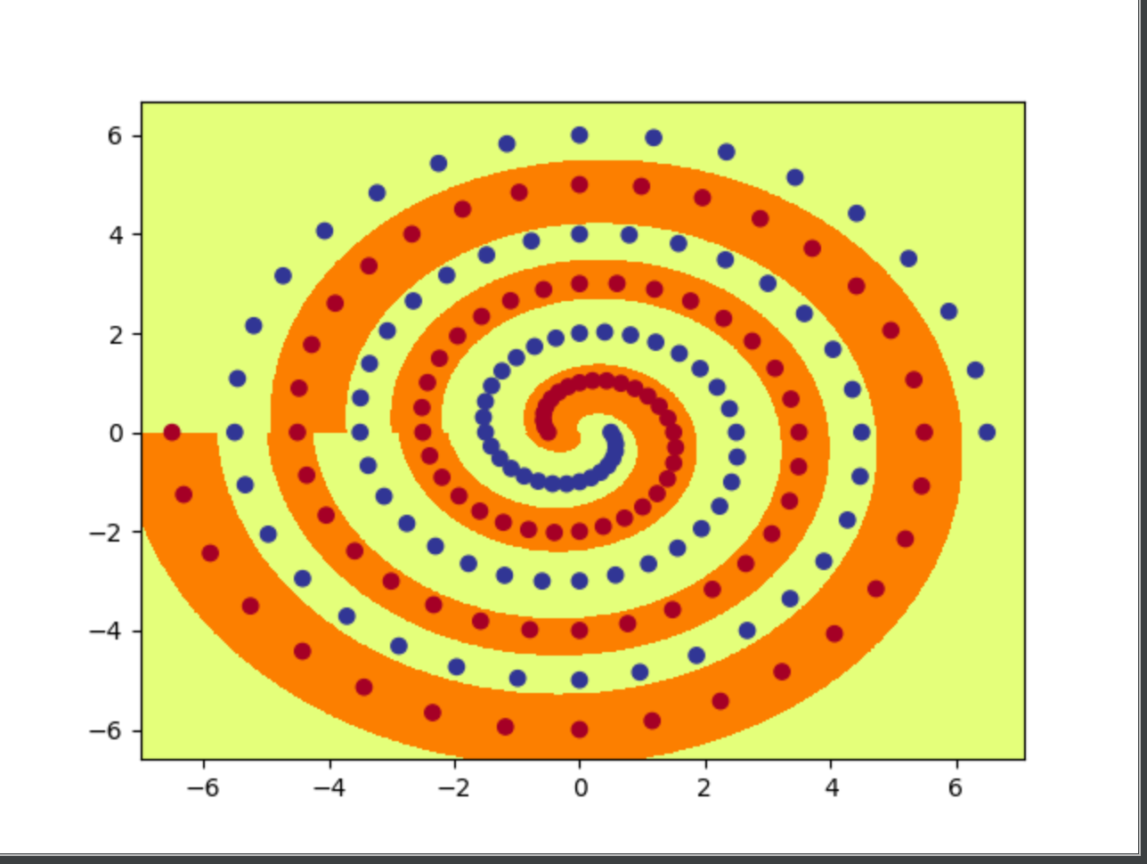

They all reach to 100% accuracy in the end.

When we try numbers less than 6 for several times, the accuracy cannot reach to 100% within 20000 epochs, e.g. running --hid = 5, we get below results.

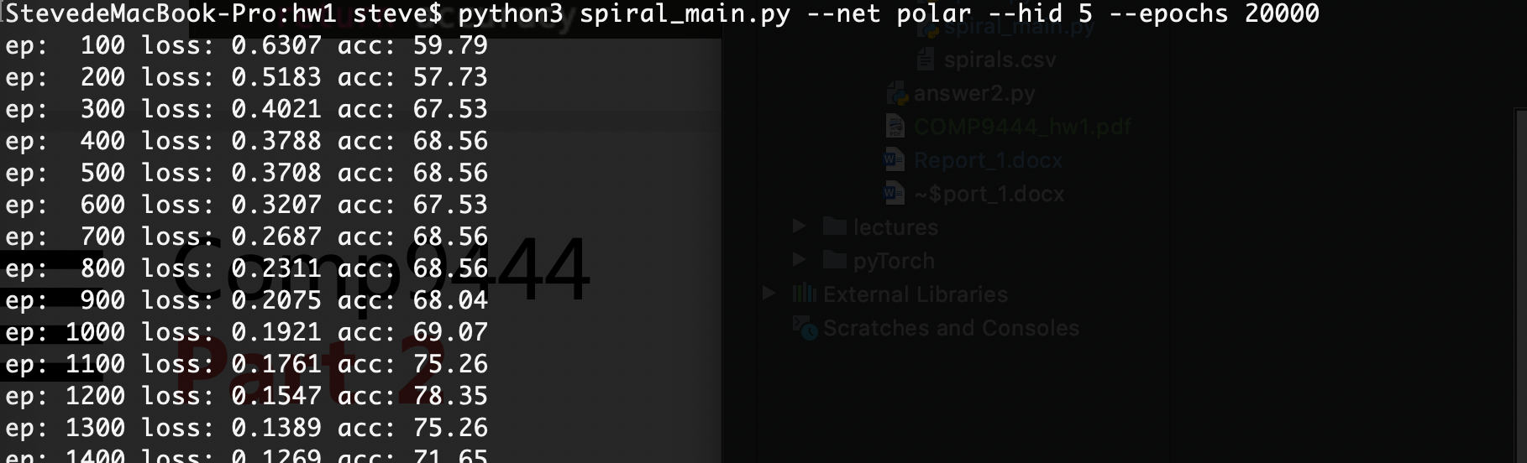

…..

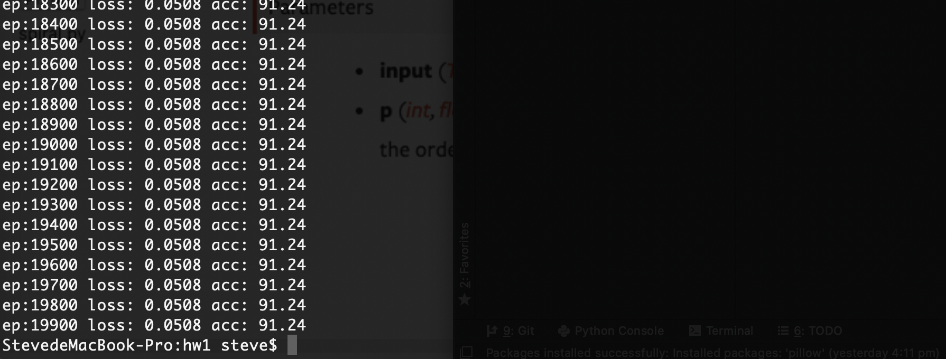

We try a lot of times running, all of them failed. And failure as well when we try --hid < 5 and the performance is even worse.

As a result, the minimum number we have found is 6.

3. code is seen in file spiral.py

4. Initially, we run initial command:

First, we can see all parameter default values:

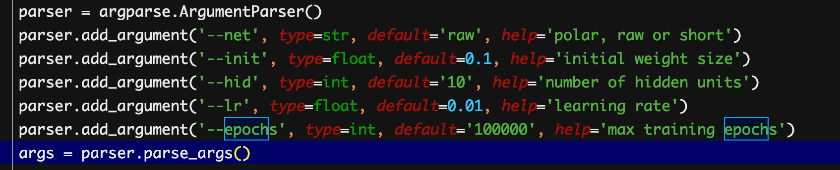

Then, we run command below:

For this particular choice:

We get --init value is: 0.1 and --hid value is: 10;

We could see in this time, accuracy failed to increase to 100% within 20000 epochs (just to around 50% in 20000 epochs);

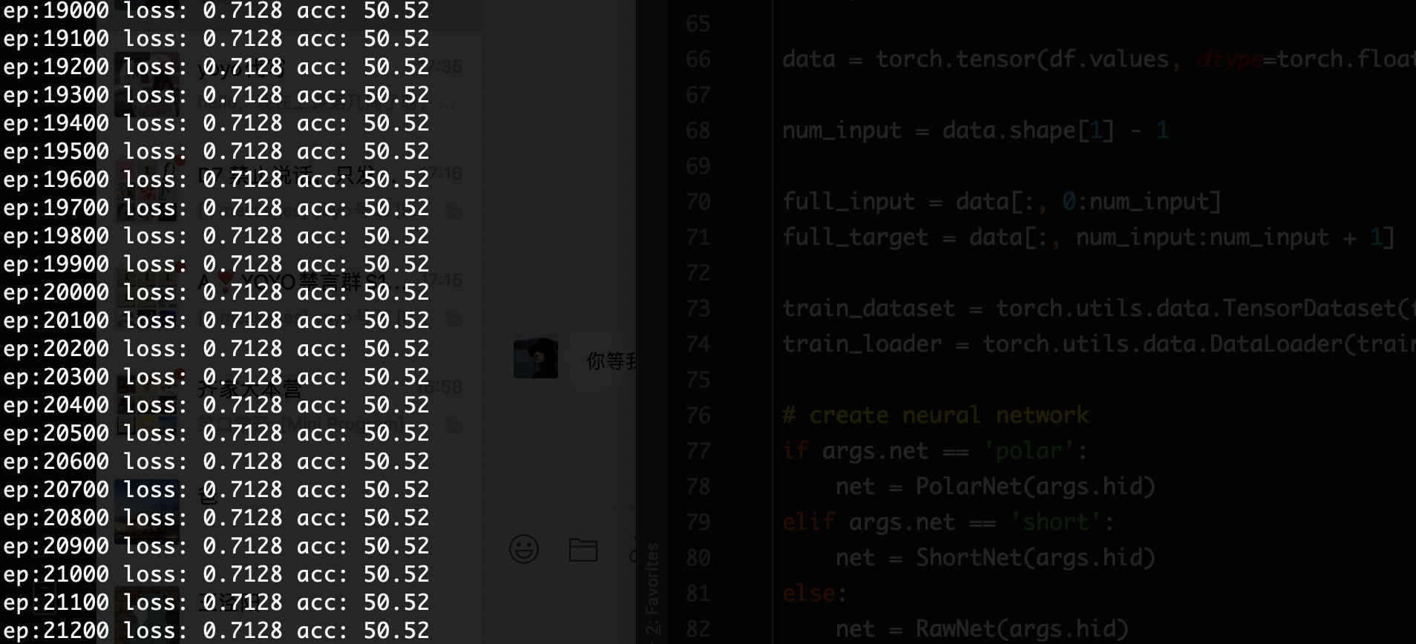

Now, we try to change –init parameter in order to get a better performance.

Firstly, we try to decrease our –init value by running such command:



We get parameters:

--init: 0.05

--epochs: 20000

--hid_num: 10 (default)

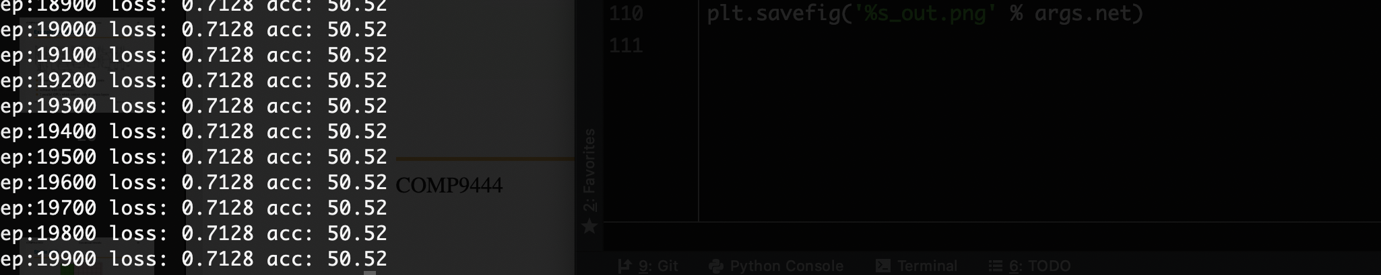

The performance is not good within 20000 epochs.

After this trial, we tried to some other group of smaller values of --init:

They all get bad results.

--init: 0.03

--epochs: 20000

--hid_num: 10 (default)

Final accuracy in 20000-th epoch: 53.27

--init: 0.05

--epochs: 20000

--hid_num: 10 (default)

Final accuracy in 20000-th epoch: 50.52

--init: 0.08

--epochs: 20000

--hid_num: 10 (default)

Final accuracy in 20000-th epoch: 51.68

In the next following steps: we tried to increase –init values greater than 0.1:

--init: 0.15

--epochs: 20000

--hid_num: 10 (default)

Result shown below:

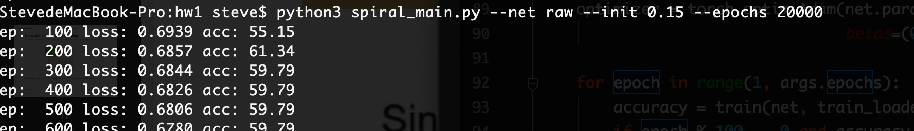

……

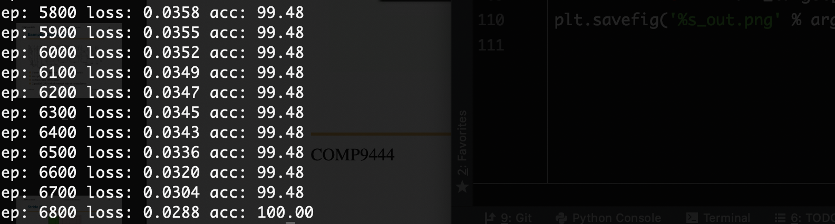

In epoch 6800, it reached to 100% acc.

Picture generated:

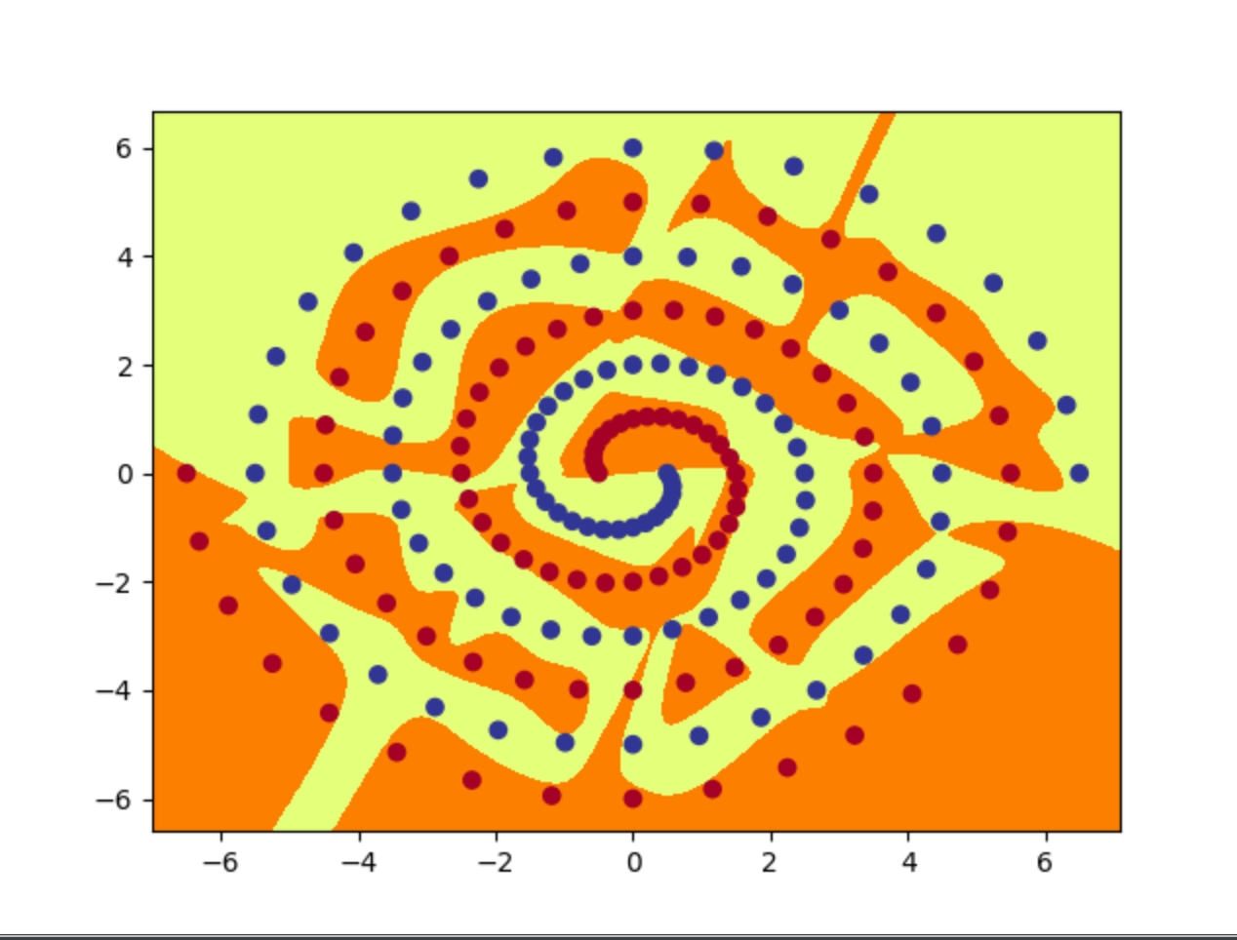

--init: 0.2

--epochs: 20000

--hid_num: 10 (default)

Final accuracy in 20000-th epoch: 53.27

Result shown below:

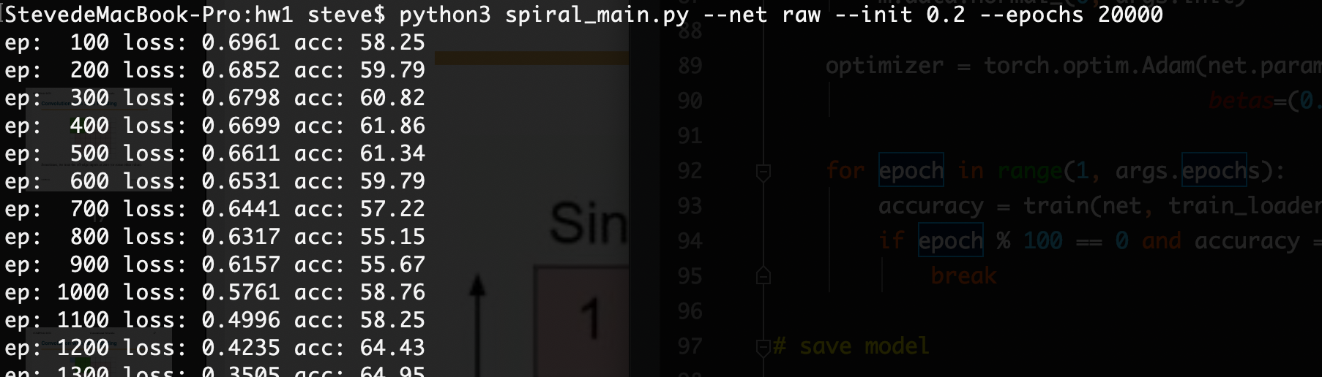

……

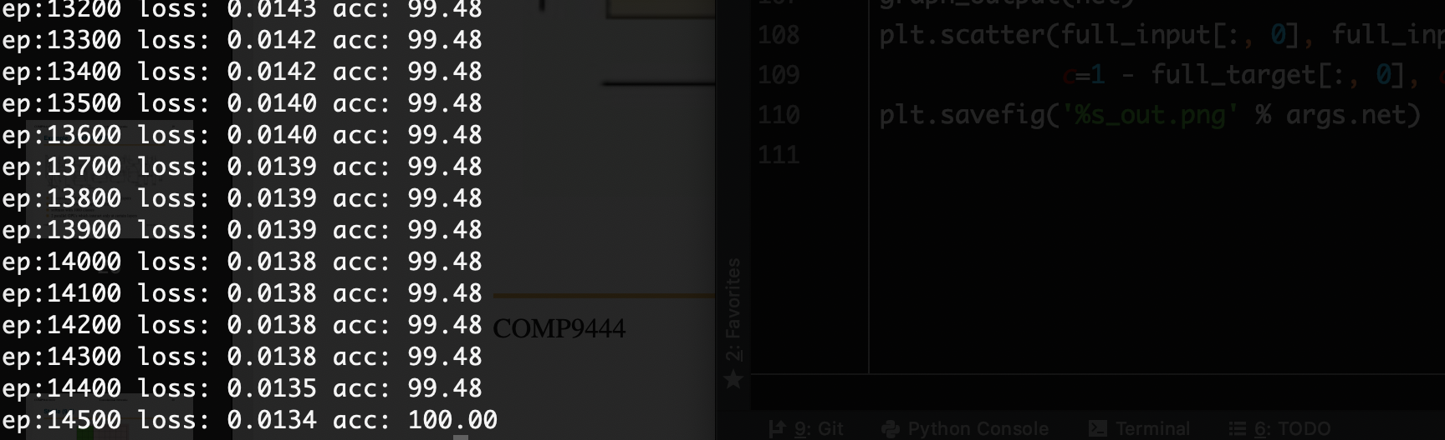

In epoch14500, it reached to 100% acc.

Picture generated:

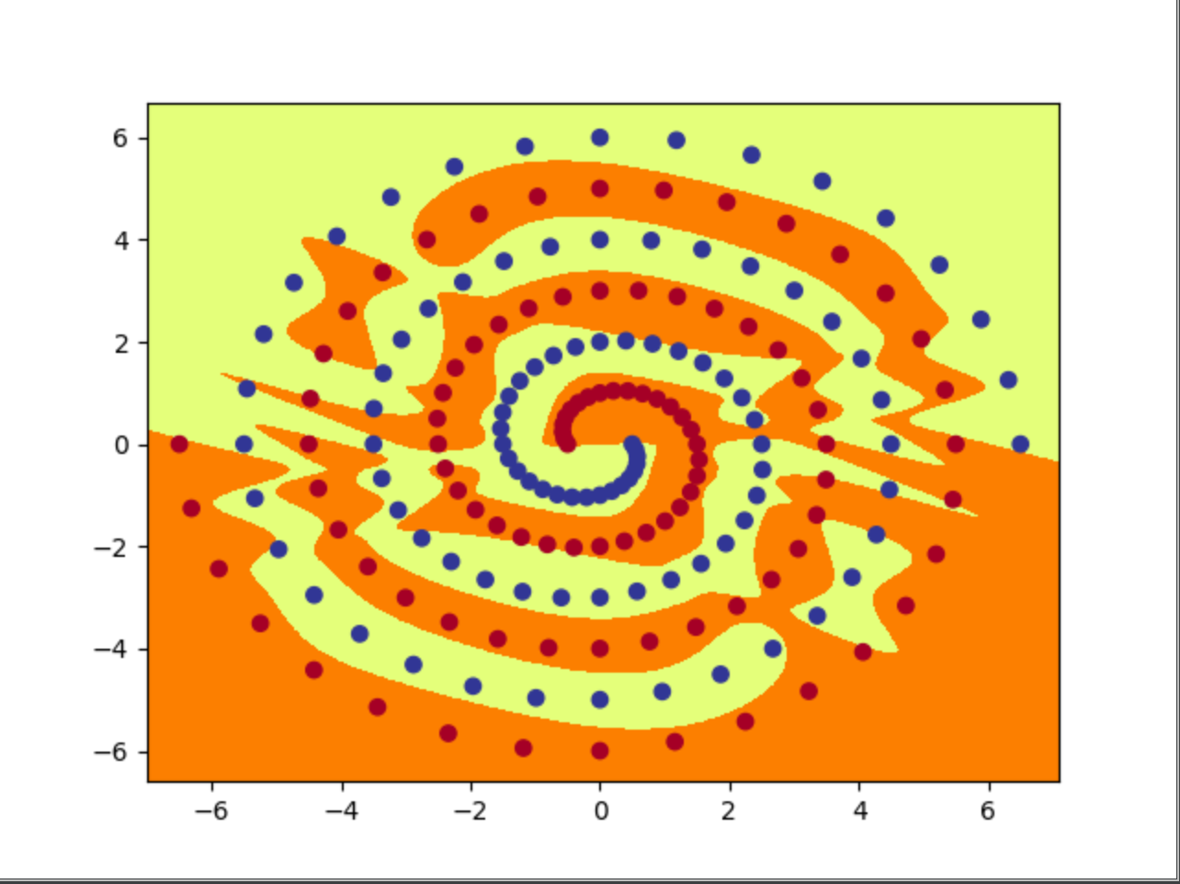

Until now we know that increasing --init value sightly may give us a better performance of accuracy. Finally, we choose 0.15 as our good –init value for our moddel.

5. code is seen in file spiral.py

6. As I tried different init value several times, I found it training is the fastest (we get 100% in epochs 2200) when init value is 0.16:

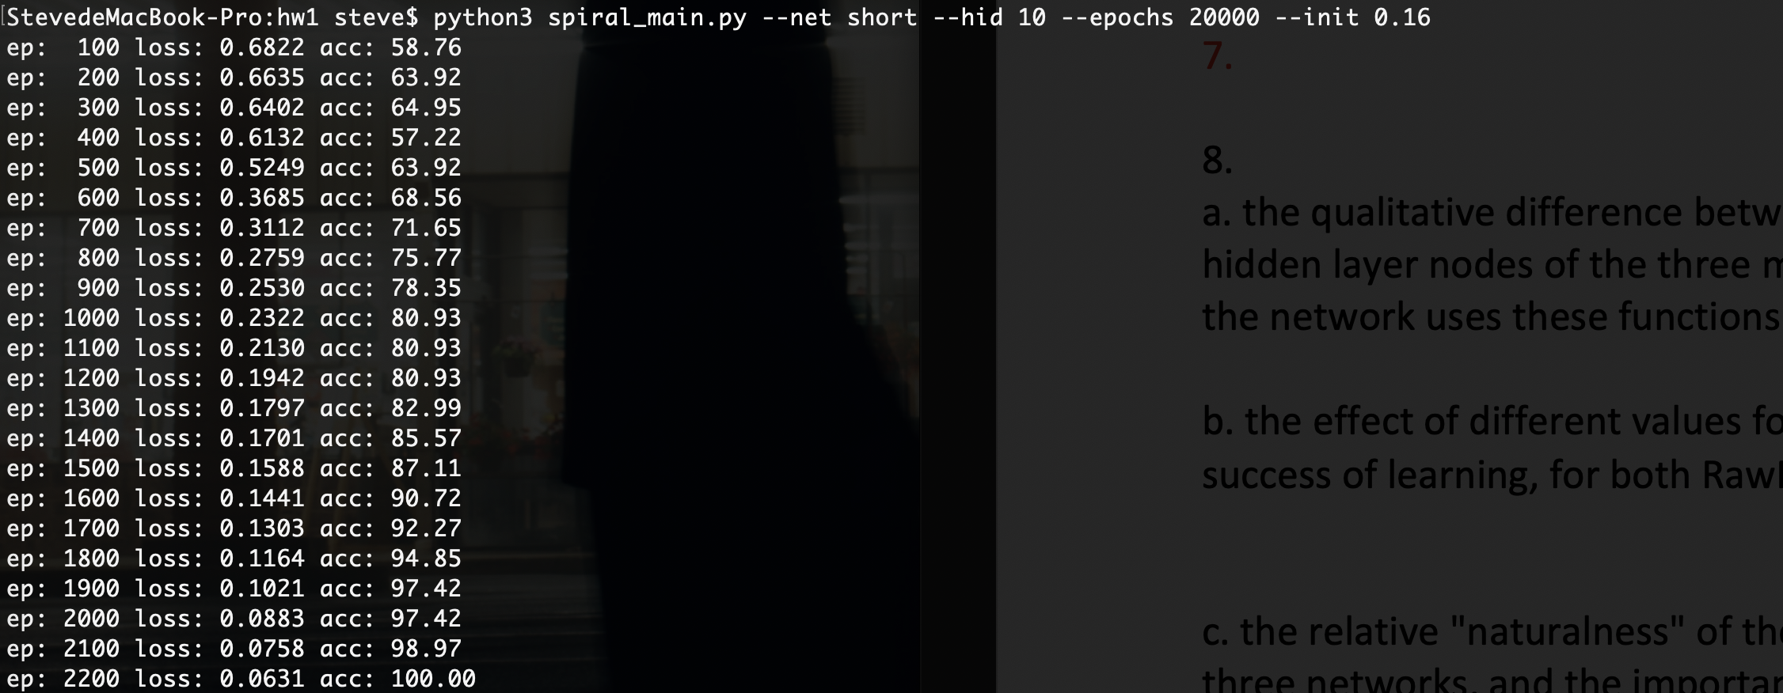

And it turns out the minimum number of hidden nodes per layer is 6. In other word, ShortNet cannot learn to correctly classify all of the training data within 20000 epochs when hidden nodes in each layer is 6.

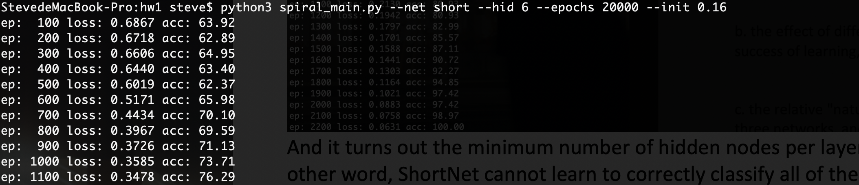

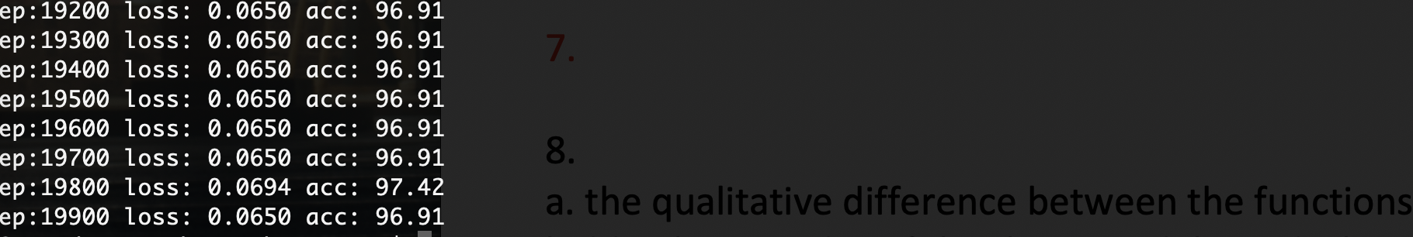

7. we have generated our hidden node pictures:

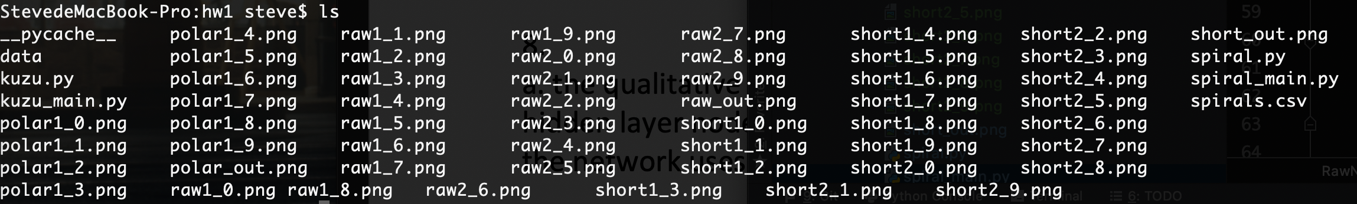

PolarNet part hidden layer1 output:

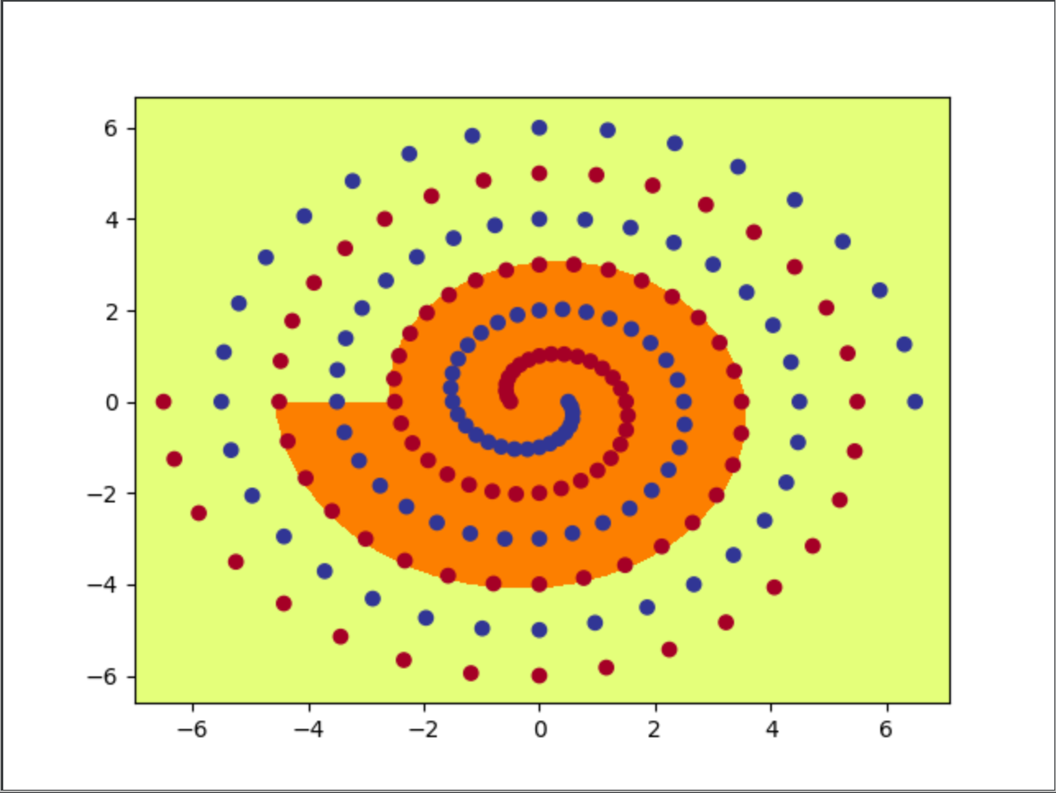

RawNet part hidden layer1 and layer2 output:

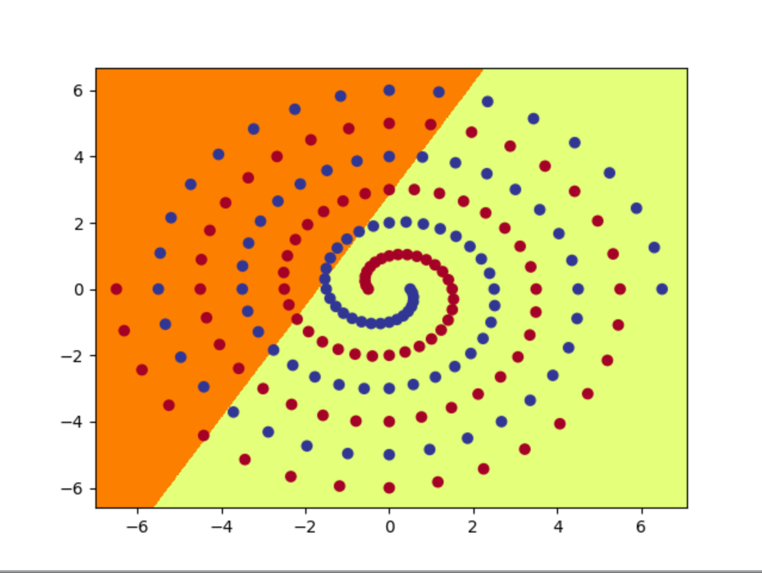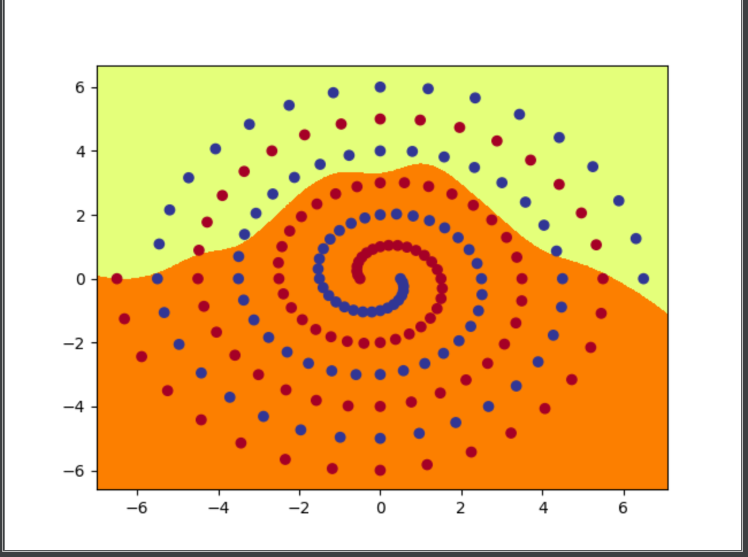

ShortNet part hidden layer1 and layer2 output:

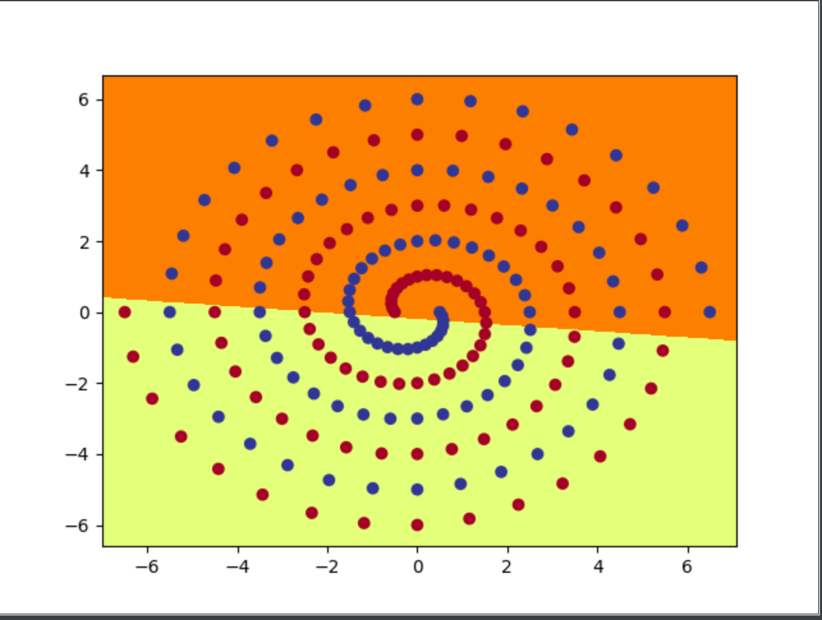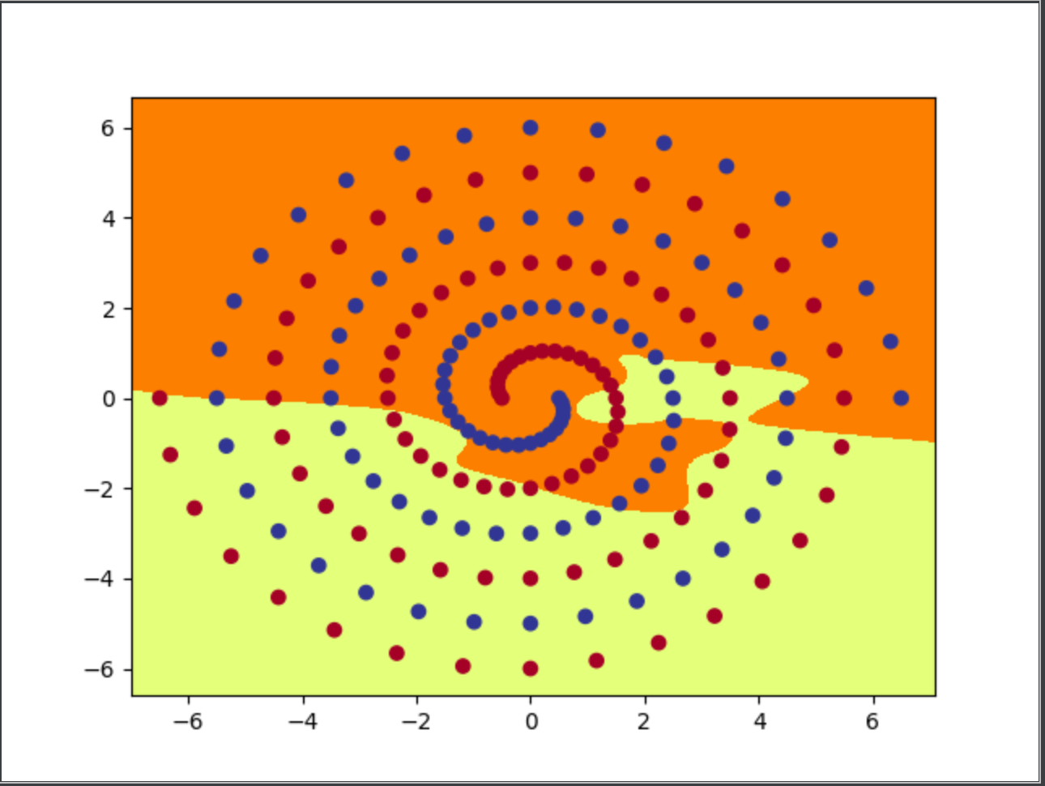

8. **Discuss what you have learned from this exercise, including the following points:**

**a. the qualitative difference between the functions computed by the hidden layer nodes of the three models, and a brief description of how the network uses these functions to achieve the classification**

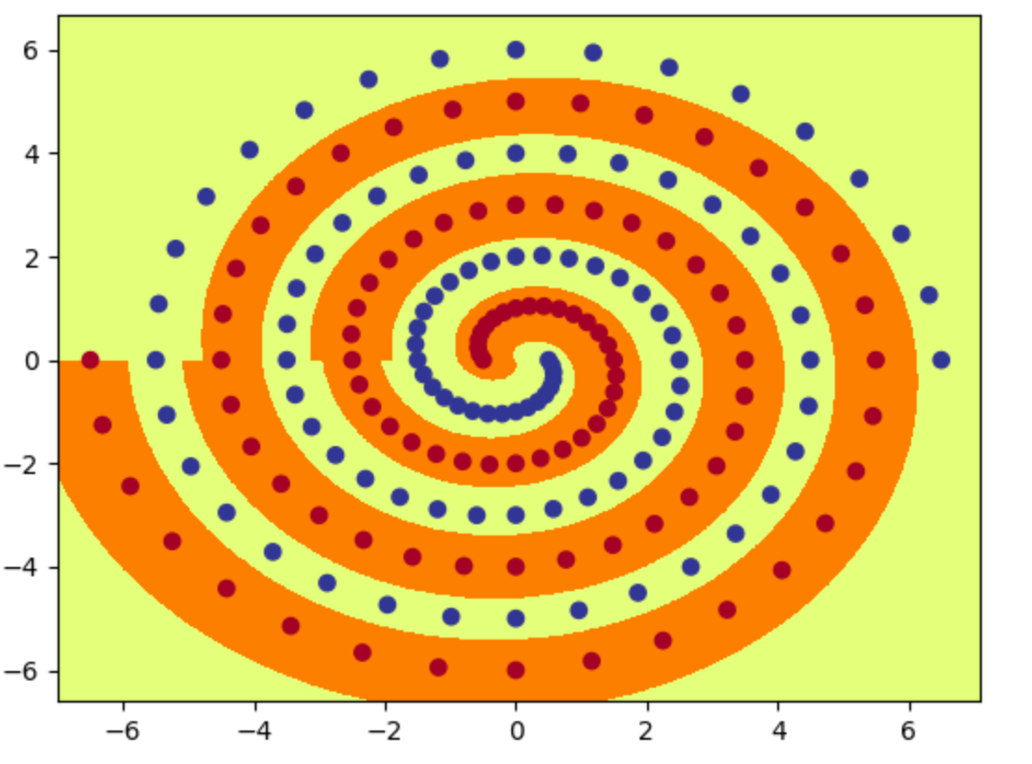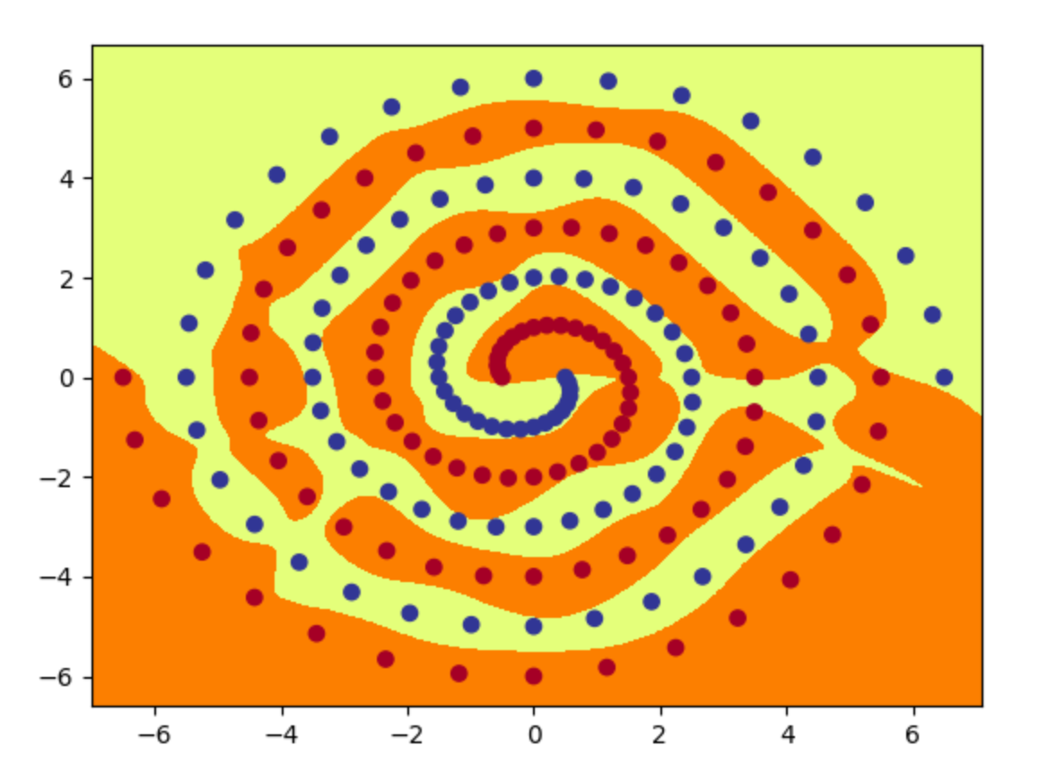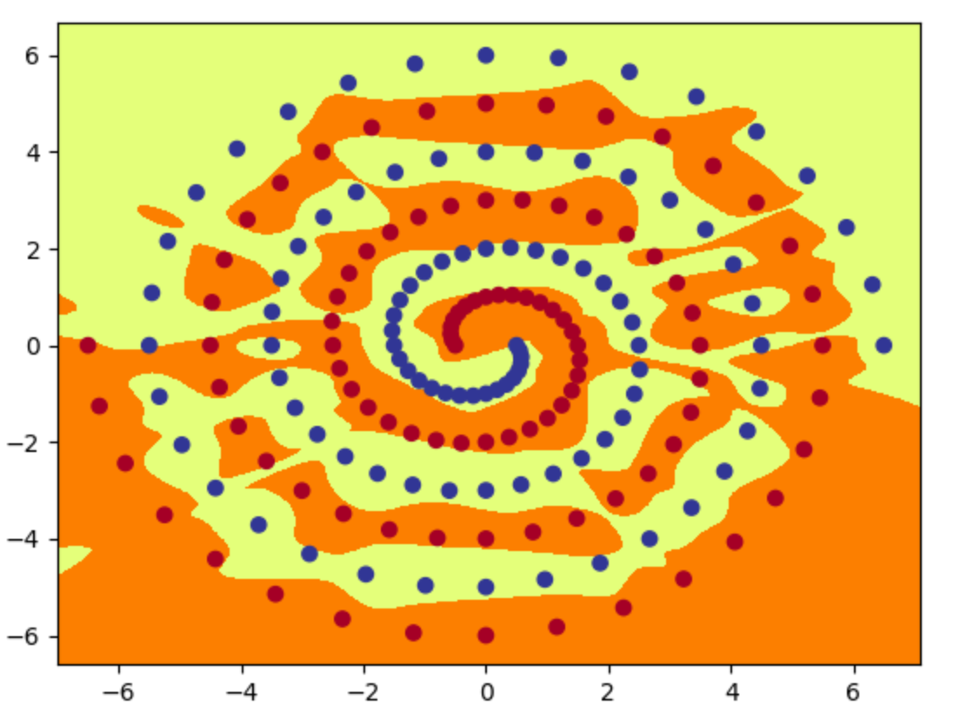

For polarNet part, there is just one hidden layer, and inputs are all converted to polar coordinate. In this case, we could see that the output in hidden layer looks more like “polar shape”, which is very similar to what we would expect from a classification. And the features filtered out by hidden layer are more in line with the requirements of our classification. A good result similar to a “polar shape” can be finally achieved though the joint action of multiple nodes.

We can only get a linear output from hidden layer 1 for both rawNet part and shortNet part as we use linear model. And we may get some curve-shape boundary in terms of outputs of hidden layer 2. As we can see, raw and short model solve this classification problem mainly based on linear and multivariable non-linear functions. As a result, they do not fit the shape of polar coordinates.

In conclusion, for this two spiral problem, polar model is more suitable using to make decisions than raw and short models.

**b. the effect of different values for initial weight size on the speed and success of learning, for both RawNet and ShortNet**

In essence, even if choosing the same value of--init parameter, we do some experiments from--init = 0.01 to 0.3 with an increment of 0.02 in both RawNet and ShortNet.

I test a list of values [0.01, 0.05, 0.1(default), 0.15, 0.2, 0.25, 0.3]:

It turns out that each result of training is random because the model initializes weights in a random way at the beginning.

For RawNet:

When we specifiy epochs 20000, it turns out if we choose –init values less than 0.1, it is relatively hard to train successfully.

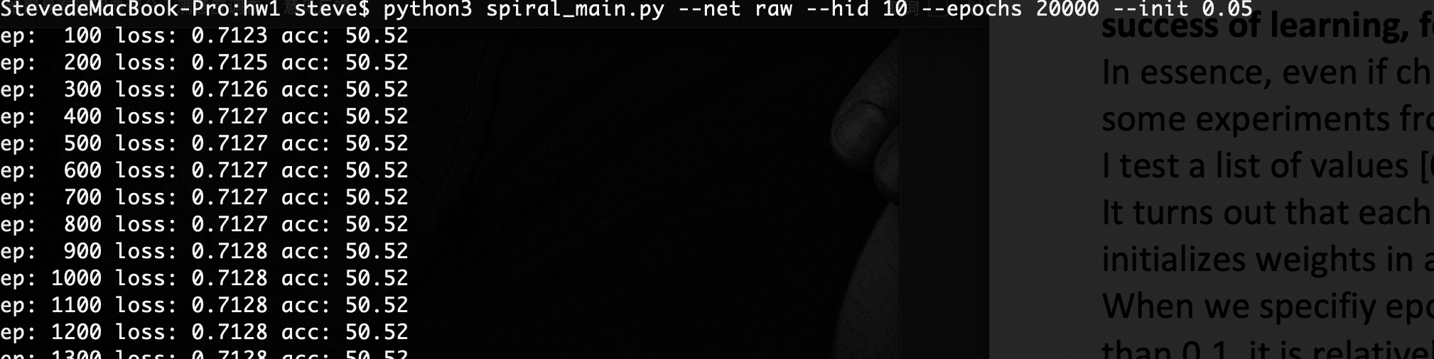

……



When –init value is larger than 0.1, model can be trained to 100% within 20000 epochs although it is still random. Sometimes it trains fast, sometimes it does not. And when init value is close to 0.3, training speed will be a little sightly slow and inaccurate.

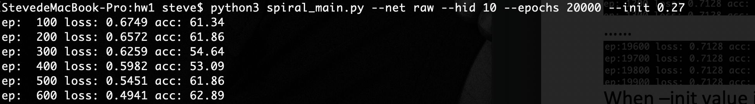

……



But it does show that an insight that the init weight matters during our training. It cannot be either too large or too small. Init value 0.13 to 0.16 show the best performance for our model.

For ShortNet:

The performance is similar to RawNet, the only difference is that the training speed is a little bit faster than RawNet in terms of average training speed.

**c. the relative "naturalness" of the output function computed by the three networks, and the importance of representation for deep learning tasks in general**

the “naturalness” of polarNet is much better than rawNet and shortNet. The reason is clear: polarNet use much simpler network structure to achieve a much more satisfied performance (it only uses one hidden layer).

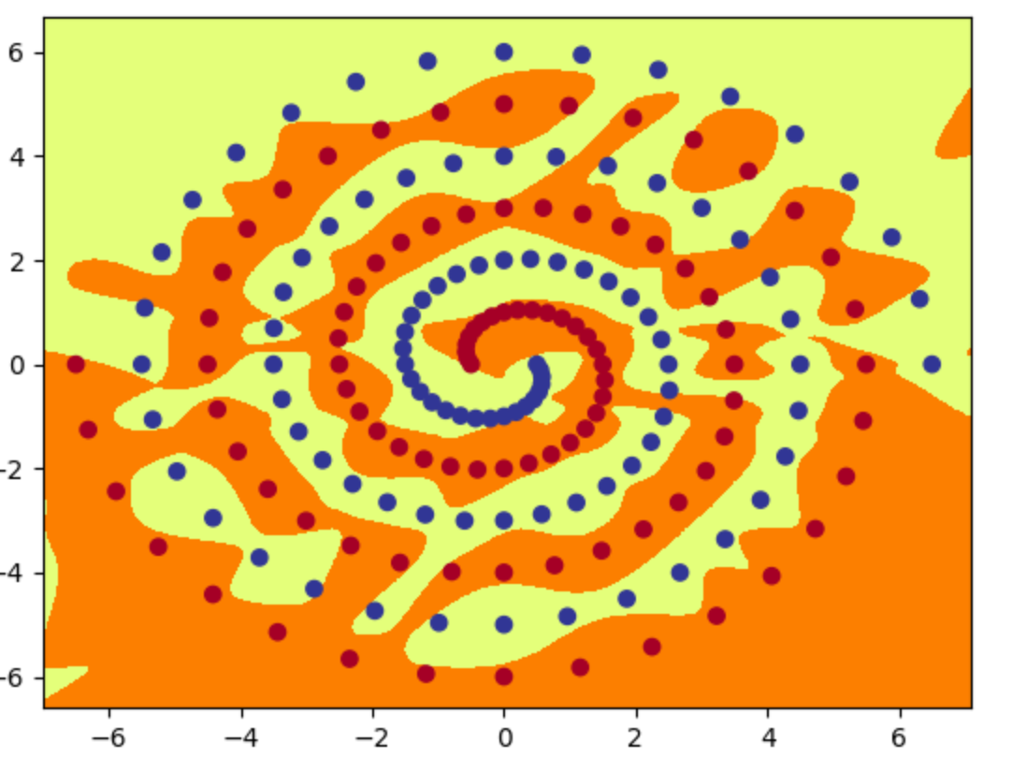

Athough rawNet and shortNet do the same effect in the training data set, they use more complex structure to implement that, and the final result is not so satisfied, because our model will perform bad on test set, it cannot predict the right shape for real shape.

the suitable input data form matters a lot, if we can choose appropriate data form for our model, not only it can simplify our model, but also obtain a better accuracy.

**d. you may like to also experiment with other changes and comment on the result - for example, changing batch size from 97 to 194, using SGD instead of Adam, changing tanh to relu, adding a third hidden layer, etc.**

Firstly I choose rawNet to do some other experiments with some changes since rawNet is relatively a Linear model.

(1) Changing batch size:

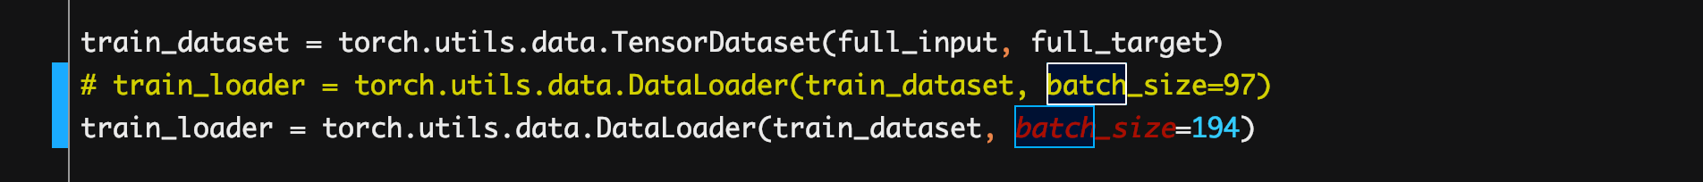

Here are figures generated when using batch size 97 and 194:

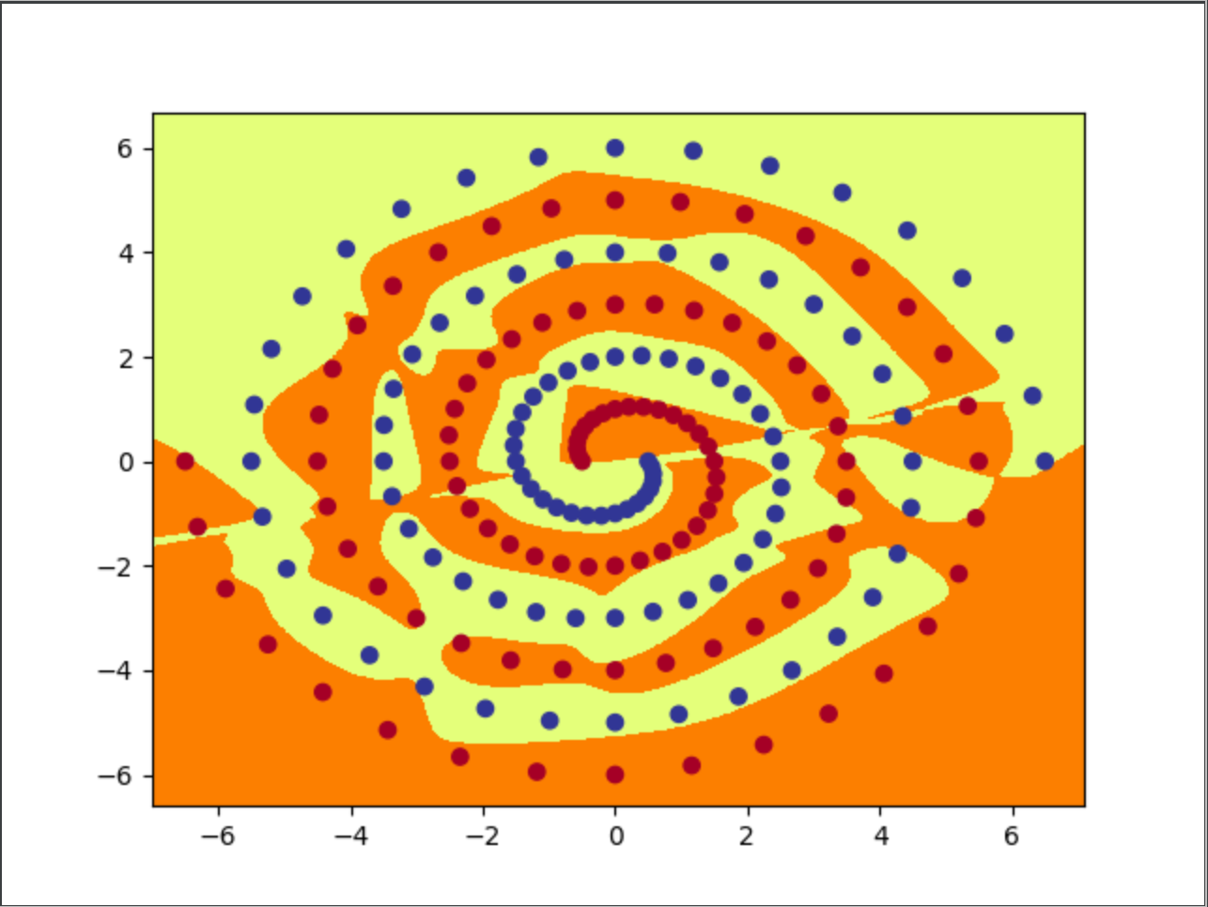 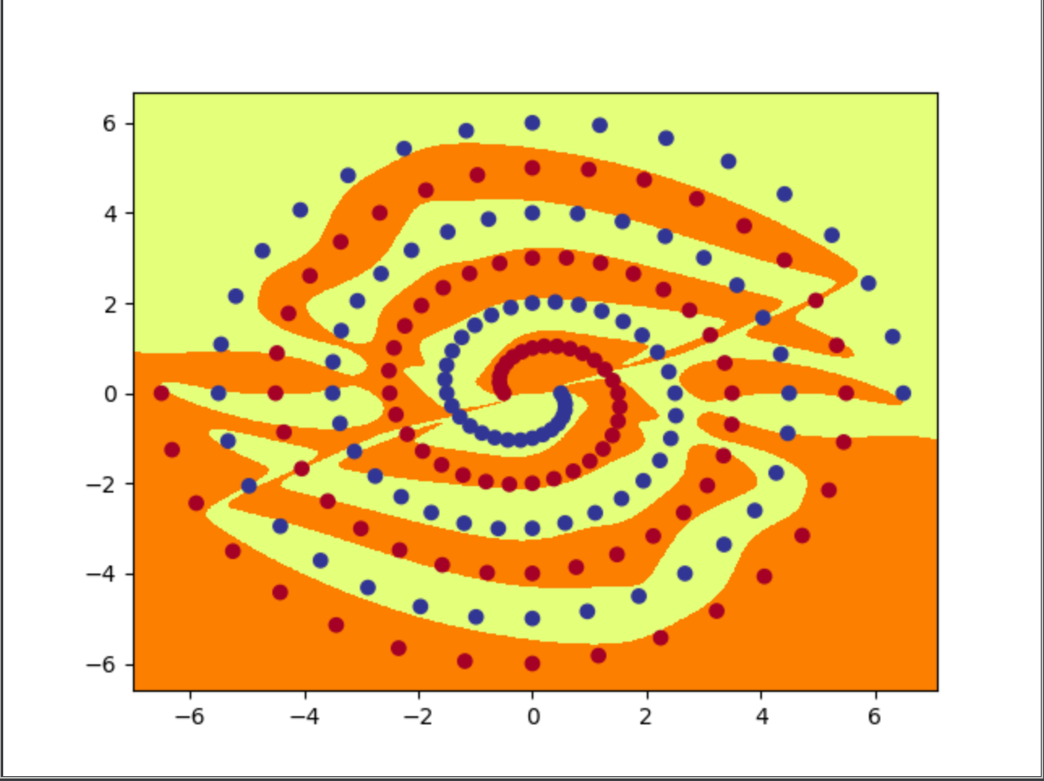

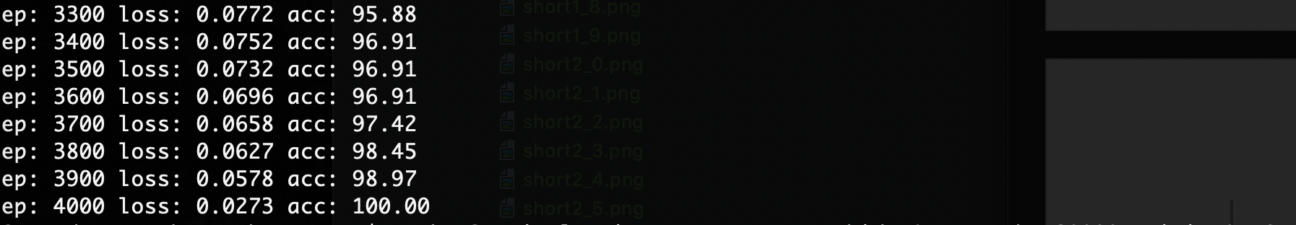

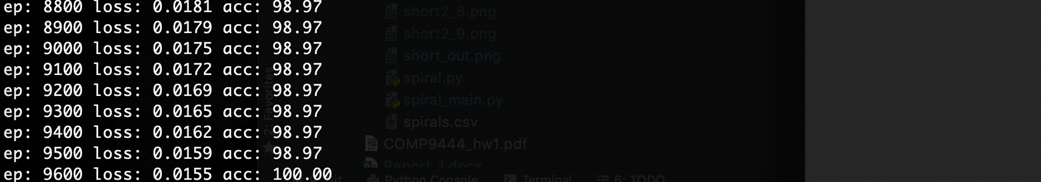

And we could see that final output figure do not change a lot, but training speed increased in some extent since our batch size increased. batch_size: 194 epoch 4000 reached 100%;

batch_size: 97 epoch 9600 reached 100%.

(2) using SGD optimizer:

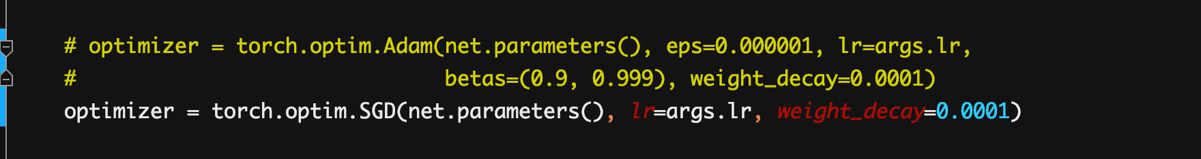

Before we change our optimizer to SGD, we obtain a relative good result.

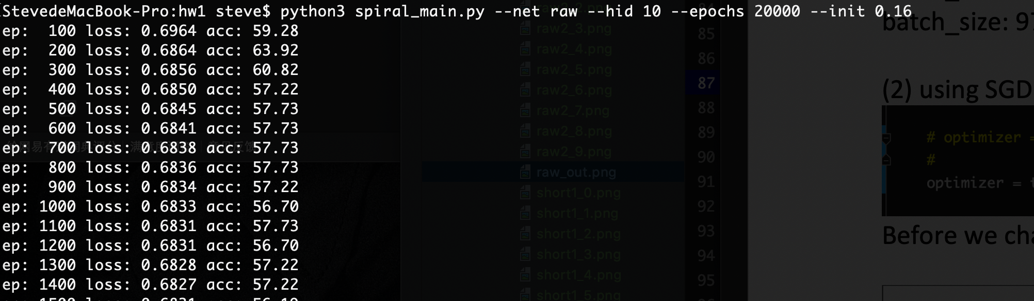

……



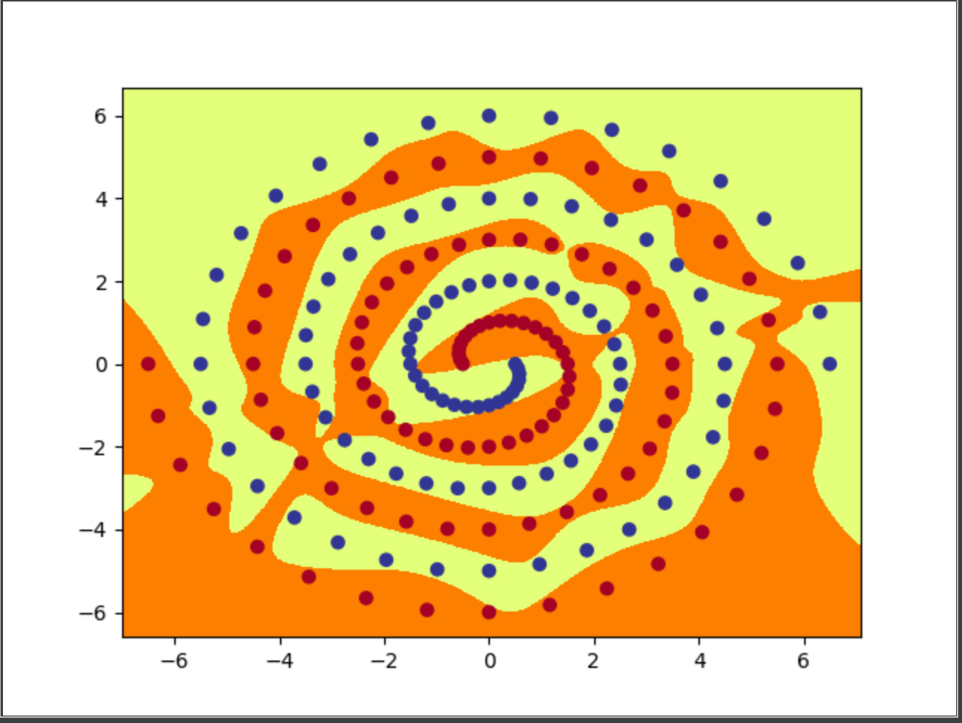 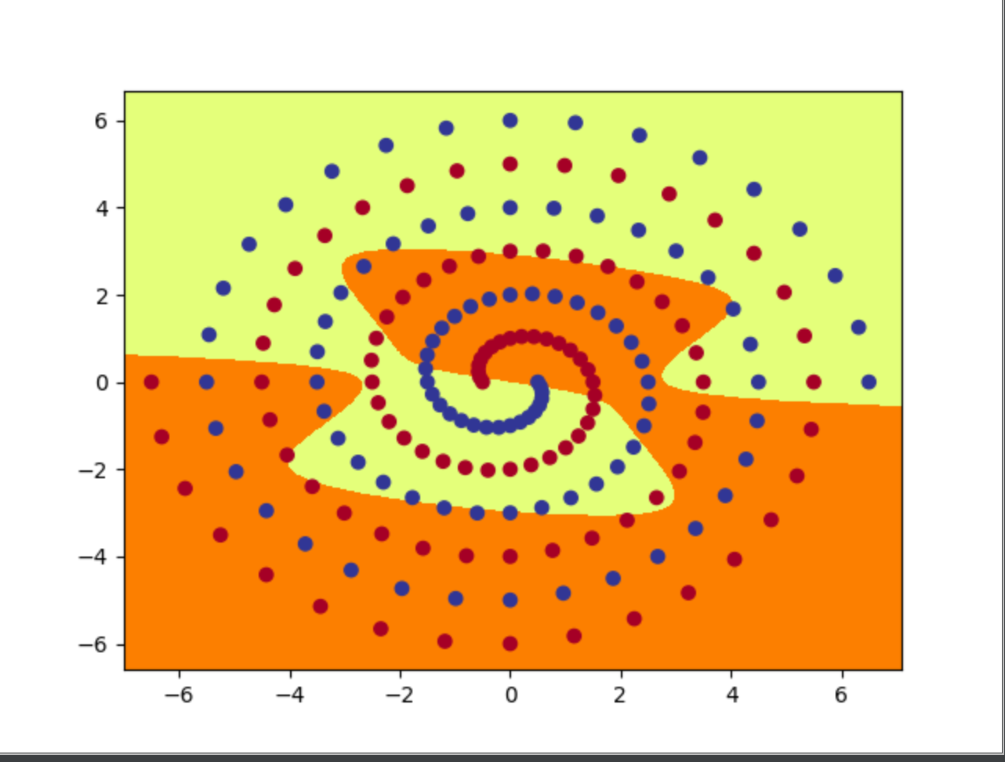

After we change model optimizer to SGD for two spiral problem:

It turns out our training process faces a very serious difficulty

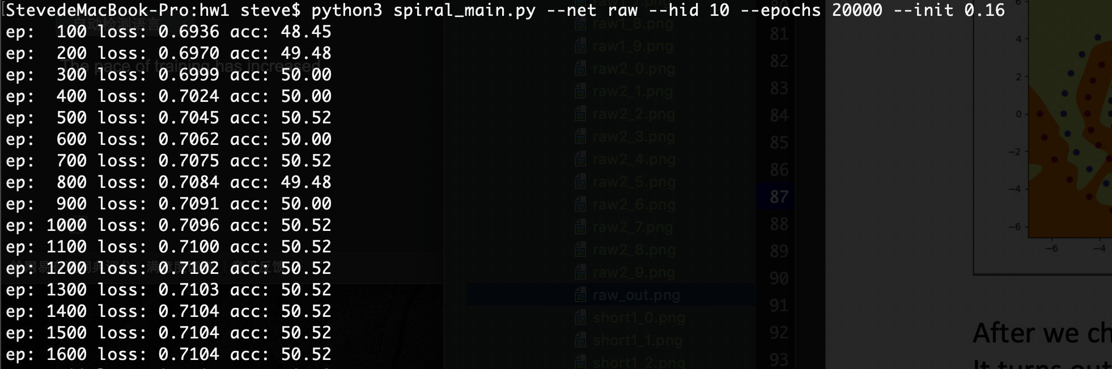

……

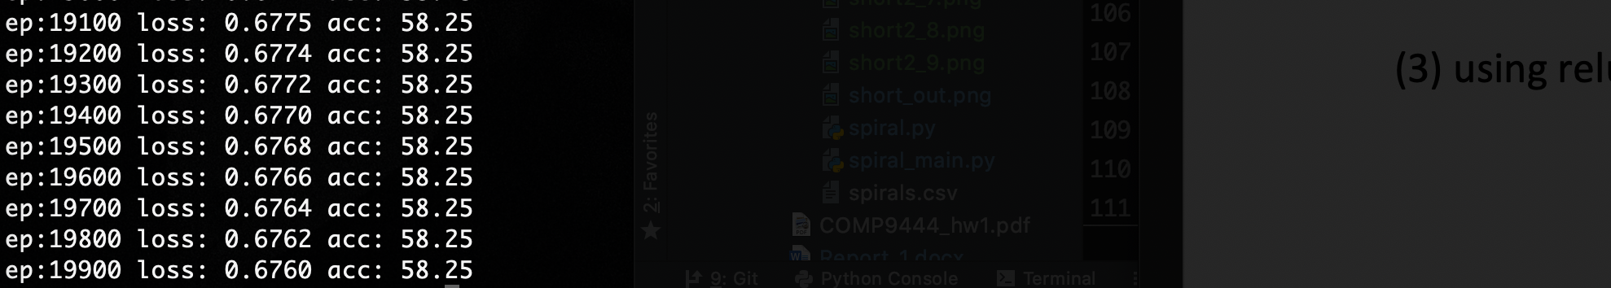

We test many times, but it shows we will get a very bad model for our problem if changing Adam to SGD. Within 20000 epochs, the accuracy is no more than 60% although we do lots of tests.

(3) using relu activation functions:

We change our activate function to ReLU, the performance of our model will be worse as well.

Since we different activation functions have different ranges:

For ReLU: range is: (0, +integer); For Tanh: range is: (-1, 1);

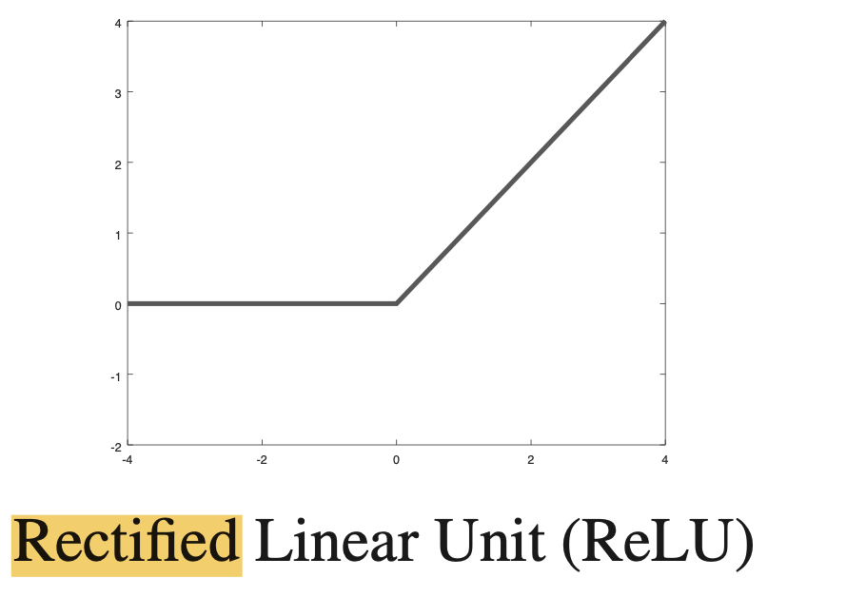 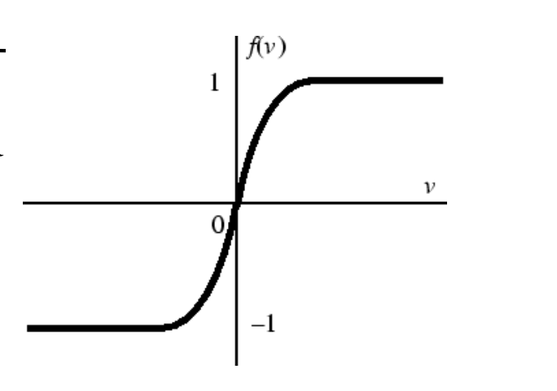

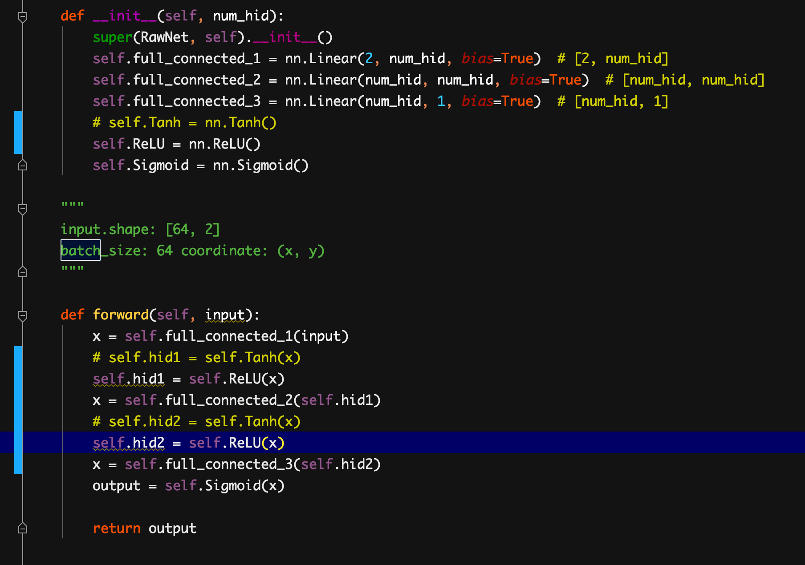

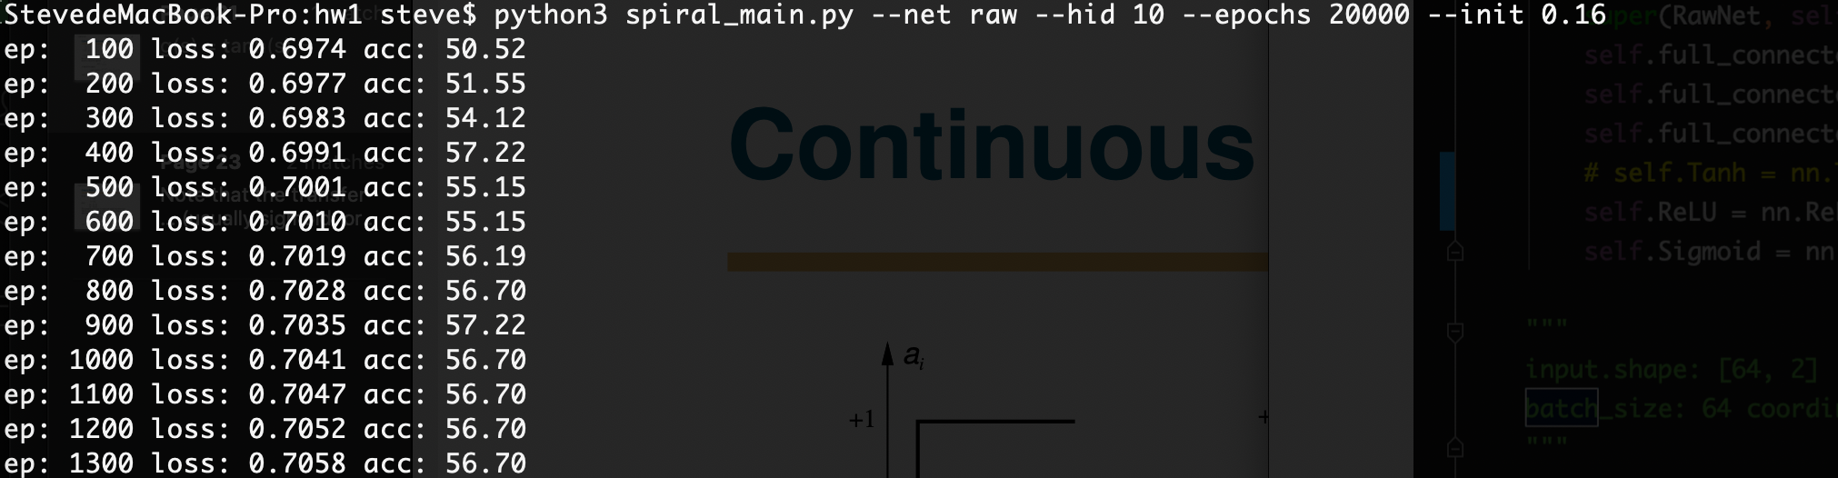

……

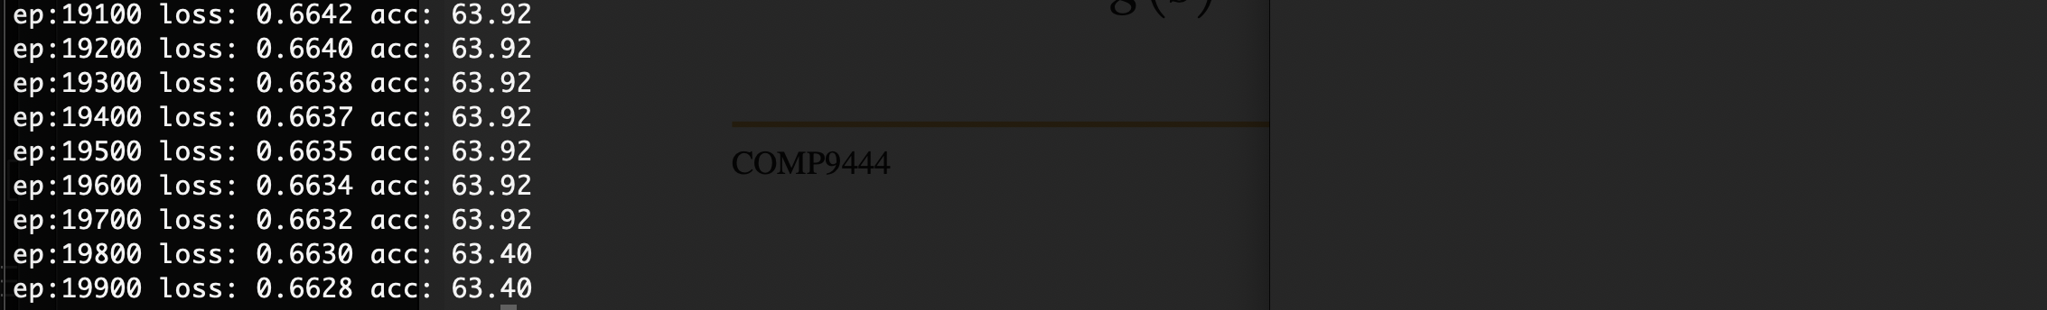

The result shows that our model find it harder to train and will get a worse accuracy at the end if we change our activation function to ReLU() in our model rawNet.

It also gives us an extra information that choosing an appropriate activation function matters when we are training a model.